POWER GRID: SMART IOT-ENABLED GRID MONITORING & MANAGEMENT

A Project Report submitted to
Jawaharlal Nehru Technological University
in partial fulfillment of the requirements for the award of Degree of

BACHELOR OF TECHNOLOGY
in
ELECTRICAL & ELECTRONICS ENGINEERING

Submitted by

Boini Rohith Roll No.:23835A0209

Under the Guidance of

Dr. Nagaraja Kumari. CH
Associate Professor



Department of Electrical & Electronics Engineering

Guru Nanak Institute of Technology

Ibrahimpatnam, Hyderabad, R.R. District – 501506

May, 2025

CERTIFICATE

This is to certify that the Mini-project/project entitled POWER GRID: SMART IOT-ENABLED GRID MONITORING & MANAGEMENT is being submitted by Mr. Boini Rohith, bearing Roll No. 23835A0209, in partial fulfillment for the award of the Degree of Bachelor of the Technology in Electrical & Electronics Engineering to the Jawaharlal Nehru Technological University is a record of Bonafide work carried out by them under my guidance and supervision.
The results embodied in this Mini-project/project report have not been submitted to any other University or Institute for the award of any Degree or Diploma

Internal Guide External Guide
Dr. Nagaraja Kumari.CH DR.CH. Sriram
Associate Professor Assistant Professor

Head of the Department
Dr. Nagaraja Kumari.CH
Associate Professor

External Examiner

Declaration of Student

We, Boini Rohith (23835A0209), Kalluri Tejeshwar (23835A0224), Sirikonda Harsha Vardhan (22831A0215), here by declare that the major project titled “POWER GRID: SMART IOT-ENABLED GRID MONITORING & MANAGEMENT” has been carried out by us as part of the requirements for the award of the Degree of Bachelor of the Technology in Electrical & Electronics Engineering at Guru Nanak Insitute of Technology.
We confirm the following:
- The project was undertaken by us under the supervision of our guide, Dr. Nagaraja Kumari.CH, from the selection of the topic to the completion of the final report.
- We have ensured that the results presented in the report are accurate and based on our original work.
- To the best of our knowledge, the content of this report is free from plagiarism and adheres to ethical standards.
- Each member of the team has contributed significantly and appropriately to the project work.
- The project report has been prepared with diligence, ensuring clarity, accuracy, and adherence to academic standards.
We further declare that this report has not been submitted, in part or full, to any other institution or university for the award of any degree or diploma.

Boini Rohith Boini Rohith
23835A0209

Kalluri Tejeshwar Kalluri Tejeshwar
23835A0224

Sirikonda Harsha Vardhan Sirikonda Harsha Vardhan
22831A0215

Date:
Place:

Declaration of Guide

I, Dr. Nagaraja Kumari.CH, hereby declare that I have guided the major project titled “POWER GRID: SMART IOT-ENABLED GRID MONITORING & MANAGEMENT” undertaken by Boini Rohith (23835A0209). This project was carried out towards the fulfillment of the requirements for the award of the Degree of Bachelor of the Technology in Electrical & Electronics Engineering at Guru Nanak Institute of Technology.
As the guide, I confirm the following:
- I have overseen the entire project process, from the selection of the project title to the submission of the final report.
- I have reviewed and certified the accuracy and relevance of the results presented in the report.
- The work carried out is original, free from plagiarism, and adheres to ethical guidelines.
- The contributions of each student have been appropriately recognized and assessed.
- The project report has been prepared under my supervision, ensuring adherence to high standards of quality, clarity, and structure.
I further certify that this project report has not been previously submitted in part or full for the award of any degree or diploma by any institution or university.

Name of Guide: Dr. Nagaraja Kumari.CH Signature of the Guide
Date:
Place:

Name of HOD: Dr. Nagaraja Kumari.CH Signature of the HOD
Department: Electrical & Electronics Engineering

Date:
Place:

ACKNOWLEDGEMENT
We would like to express our sincere gratitude to our internal guide, Dr. Nagaraja Kumari.CH, Associate Professor, Electrical & Electronics Engineering, for her valuable guidance, encouragement, and continuous support throughout the duration of this project.
We are also thankful to Dr. Nagaraja Kumari.CH, Associate Professor, Electrical & Electronics Engineering, for her expert supervision and helpful suggestions, which contributed significantly to the successful completion of this project.
We would also like to thank the faculty members of Electrical & Electronics Engineering the and the Lab Technicians for their assistance and cooperation during the practical work of our project.
We are grateful to our friends and well-wishers for their encouragement, collaboration, and useful feedback throughout the project journey.
Lastly, we sincerely thank our parents for their constant support, patience, and motivation, which helped us complete this project successfully.

Boini Rohith [Roll No.: 23835A0209]

ABSTRACT
The increasing demand for reliable and efficient energy distribution has made smart grid technologies essential for modern power infrastructure. Power Grid is an IoT-enabled grid monitoring and management system designed to enhance real-time power distribution, fault detection, and energy optimization. By integrating IoT sensors, AI-driven analytics, and cloud connectivity, Power Grid ensures improved grid stability, reduced downtime, and enhanced operational efficiency.
The system continuously monitors key grid parameters such as voltage, current, frequency, power load, and fault occurrences using IoT-enabled sensors deployed across the grid. Real-time data is transmitted to a cloud-based dashboard, where AI-driven analytics predict failures, optimize energy flow, and generate instant alerts for grid anomalies. The system also supports automated load balancing, demand response management, and remote control of grid components via a web or mobile application. Additionally, PowerGrid+ facilitates integration with renewable energy sources, promoting sustainable power management.
By offering real-time monitoring, predictive maintenance, and automated grid control, Power Grid enhances energy reliability, reduces operational costs, and supports the transition to a smarter and more sustainable power grid. This innovative solution is crucial for modernizing power infrastructure and ensuring efficient energy distribution.

LIST OF FIGURES
FIGURE | TITLE | PAGE NUMBER
3.1.1 | Layered Architecture of an Embedded System | 6
3.1.2 | CPU | 7
3.2 | Block Diagram | 9
3.3.1 | Block Diagram Of Power Supply | 10
3.3.2 | Bridge Rectifier | 11
3.3.3 | Output Waveform Of DC | 11
3.3.4 | Regulator | 12
3.3.5 | Circuit Diagram Of Power Supply | 12
3.4 | ESP8266 NodeMCU | 16
3.5 | NodeMCU ESP8266 Pinout | 16
3.6 | Buzzer | 36
3.7 | Bluetooth packet structure | 40
3.8 | Discovering a Bluetooth device | 40
3.9 | Position of audio in Bluetooth stack | 41
3.10 | Stages in setting up an SDP session | 44
3.11 | Bluetooth profiles | 45
3.12 | QoS Messaging | 49
3.13 | Types of LEDs | 51
3.14 | Circuit Diagram of ULN2003 | 52
3.15 | Logic Diagram of ULN2003 | 52
3.16 | Relay | 53
3.17 | Representation of Relay | 54
3.18 | Motor | 55

LIST OF TABLES
Table No | Name | Page No
3.3.1 | NODEMCU Development Board Pinout Configuration | 15
3.3.2 | Function of pin OLED | 27

ABBREVIATIONS/ NOTATIONS/ NOMENCLATURE

LED Light Emitting Diode
OLED Organic Light Emitting Diode
LCD Liquid Crystal Display
DC Direct Current
AC Alternating Current
PWM Pulse Width Modulation
UART Universal Asynchronous Receiver Transmitter
I2C Inter-Integrated Circuit
I2S Inter-IC Sound
MCU Microcontroller Unit
GPIO General Purpose Input/Output
IDE Integrated Development Environment
EEPROM Electrically Erasable Programmable Read-Only Memory
RAM Random Access Memory
ROM Read Only Memory
IC Integrated Circuit
COM Common Pin
ACL Asynchronous Connection-Less
SCO Synchronous Connection-Oriented
RFCOMM Radio Frequency Communication
FEC Forward Error Correction
MAC Address Media Access Control Address
TDD Time Division Duplex
TDMA Time Division Multiple Access
IoT Internet of Things
VCC Voltage Common Collector
GND Ground
Tx / Rx Transmit / Receive
DVD Digital Versatile Disc
USB Universal Serial Bus
RS232 / RS485 Recommended Standard communication interfaces
IR Infrared

INDEX
CONTENT
Page No.

CERTIFICATE | i
ACKNOWLEDGEMENT | ii
DECLARATION | iii
VISION OF THE DEPARTMENT | iv
ABSTART | v
LIST OF FIGURES | vi
LIST OF TABLES | vii
ABBREVIATIONS/ NOTATIONS/NOMENCLATURE | viii
CHAPTER 1
1 INTRODUCTION | 1
1.1 General introduction | 1
1.2 Existing System | 1
1.3 Proposed System | 1
CHAPTER 2
2 LITERATURE SURVEY | 2
2.1 Literature Survey 1 | 2
2.2 Literature Survey 2 | 2
CHAPTER 3
3 DESIGN AND DEVELOPMENT | 3-64
3.1General Introduction To Embedded System | 3
3.2 Block Diagram | 9
3.3 Modules | 10-64
1 Power Supply | 10-12
2 Micro Controller | 13-24
3 Oled | 24-27
4 Internet Of Things (Iot) | 27-35
5 Buzzer | 35-36
6 Bluetooth | 36-54
7 Software Specifications | 54-64
CHAPTER 4
4 RESULT AND DISCUSSION | 65-70
Implementation
4.1 Code | 65-68
4.2 Schematic Diagram | 69
4.3 Output Result | 70
CHAPTER 5
CONCLUSION | 71
REFERENCE | 72

CHAPTER 1
INTRODUCTION
1.1 GENERAL
The World Health Organization (WHO) reported that 92% of
the world population suffers from poor air quality and many
industrial countries struggle to reduce air pollution for their
citizens (Mercola 2016). The WHO reports that China had the
most deaths attributable to poor air quality in 2012 at
1,032,833 while the USA had 38,043 deaths attributed to poor
air quality (Kennedy 2016).
A study of 117 Canadian regions was conducted between
2007 and 2014 with support from the Harvard Clean Air
Research Center. This study examined the association be-
tween exposure to PM
2.5
and health data for people 44 years
or older. For each region, the type and size of power plants
were used to estimate clean energy production, while data on
sales of gasoline was used to compare the intensity of emis-
sions from motor vehicles. A minor increase of 10 μg/m
3
PM
2.5
in particulate matter over a 2-year average wa
As the population is increases the demand of energy is also increases at faster rate than energy supply. As increase in energy consumption greenhouse gas emissions problem also increase and it can harm the environment. With the increase in energy costs , customer expectations also increasing. Customers want to do more to protect environment , use less energy and control their cost. One of the main issues with today's outdated grid deal with efficiency. The grid become overloaded during peak time or seasons. It is also possible to hack the system, and basically take free electricity.
SMART GRID SYSTEM The smart grid is decentralised system where power flows in both direction , from generation end to consumer end and vice versa. Smart grids are based on communication between provider and consumer. It is energy consumption monitoring and measuring system. With the help of smart grid consumer and owner get daily electricity consumption reading and owner can cut electricity through internet if bill is not paid.
Smart grid can be complement of traditional electric grid system by including renewable energy resources, such as wind, solar and biomass, which is environmentally cleaner as compared to fossils fuels.
1.2 EXISTING SYSTEM:
Current grid management systems often rely on traditional infrastructure and manual operations, which can lead to inefficiencies, delayed responses to power demands, and difficulties in integrating renewable energy sources.

1.3 PROPOSED SYSTEM:
The proposed IoT-based smart grid management system leverages IoT sensors, advanced data analytics, and real-time communication technologies to optimize the monitoring and control of electrical grids. By enabling dynamic demand response, predictive maintenance, and seamless integration of renewable energy sources, this system aims to enhance grid efficiency, reliability, and sustainability, providing a more resilient and adaptive power management solution.

CHAPTER 2
LITERATURE SURVEY

2.1 Literature Survey 1

Title of the paper 1: An Iot-Based Method for Managing Power Grids In Smart Way
Journal: 2022, Intelligent Systems and Applications in Engineering
Authors: Semra Gundu, Saif Ali Gaeed
Methodology Adopted:
Iot-Based Architecture Integrating Sensors and Smart Meters For Real-Time Grid Monitoring
Use Of Cloud Platforms for Data Storage and Analysis
Algorithms For Fault Detection and Energy Optimization
Key findings:
- Improved response time in detecting grid anomalies
- Enhanced energy management through predictive analytics
- Demonstrated reduction in energy loss by up to 15%

2.1 Literature Survey 2

Title of the paper 2: Neuro-Fuzzy-Based Iot Assisted Power Monitoring System For Smart Grid
Journal: 2021, Department of Electrical and Instrumentation Engineering, Thapar Institute of Engineering and Technology
Authors: Smarajit Ghosh
Methodology Adopted:
Integration of loT devices for real-time data acquisition
Monitoring system developed to analyze grid parameters and identify anomalies
Performance validated using MATLAB simulation tools
Key findings:
- Improved accuracy in anomaly detection within the smart grid
- Neuro-fuzzy approach shows high adaptability to dynamic grid environments
- Effective real-time monitoring using hybrid

CHAPTER 3

DESIGN AND DEVELOPMENT

3.1 GENERAL INTRODUCTION TO EMBEDDED SYSTEM
An embedded system can be defined as a computing device that does a specific focused job. Appliances such as the air-conditioner, VCD player, DVD player, printer, fax machine, mobile phone etc. are examples of embedded systems. Each of these appliances will have a processor and special hardware to meet the specific requirement of the application along with the embedded software that is executed by the processor for meeting that specific requirement. The embedded software is also called “firm ware”. The desktop/laptop computer is a general-purpose computer. You can use it for a variety of applications such as playing games, word processing, accounting, software development and so on. In contrast, the software in the embedded systems is always fixed listed below:
· Embedded systems do a very specific task they cannot be programmed to do different things. Embedded systems have very limited resources, particularly the memory. Generally, they do not have secondary storage devices such as the CDROM or the floppy disk. Embedded systems have to work against some deadlines. A specific job has to be completed within a specific time. In some embedded systems, called real-time systems, the deadlines are stringent. Missing a deadline may cause a catastrophe-loss of life or damage to property. Embedded systems are constrained for power. As many embedded systems operate through a battery, the power consumption has to be very low.
· Some embedded systems have to operate in extreme environmental conditions such as very high temperatures and humidity.
Application Areas
Nearly 99 per cent of the processors manufactured end up in embedded systems. The embedded system market is one of the highest growth areas as these systems are used in very market segment- consumer electronics, office automation, industrial automation, biomedical engineering, wireless communication, data communication, telecommunications, transportation, military and so on.
Consumer appliances:
At home we use a number of embedded systems which include digital camera, digital diary, DVD player, electronic toys, microwave oven, remote controls for TV and air-conditioner, VCO player, video game consoles, video recorders etc. Today’s high-tech car has about 20 embedded systems for transmission control, engine spark control, air-conditioning, navigation etc. Even wristwatches are now becoming embedded systems. The palmtops are powerful embedded systems using which we can carry out many general-purpose tasks such as playing games and word processing.
Office Automation:
The office automation products using embedded systems are copying machine, fax machine, key telephone, modem, printer, scanner etc.
Industrial Automation:
Today a lot of industries use embedded systems for process control. These include pharmaceutical, cement, sugar, oil exploration, nuclear energy, electricity generation and transmission. The embedded systems for industrial use are designed to carry out specific tasks such as monitoring the temperature, pressure, humidity, voltage, current etc., and then take appropriate action based on the monitored levels to control other devices or to send information to a centralized monitoring station. In hazardous industrial environment, where human presence has to be avoided, robots are used, which are programmed to do specific jobs. The robots are now becoming very powerful and carry out many interesting and complicated tasks such as hardware assembly.
Medical Electronics:
Almost every medical equipment in the hospital is an embedded system. These equipments include diagnostic aids such as ECG, EEG, blood pressure measuring devices, X-ray scanners; equipment used in blood analysis, radiation, colonoscopy, endoscopy etc. Developments in medical electronics have paved way for more accurate diagnosis of diseases.
Computer Networking:
Computer networking products such as bridges, routers, Integrated Services Digital Networks (ISDN), Asynchronous Transfer Mode (ATM), X.25 and frame relay switches are embedded systems which implement the necessary data communication protocols. For example, a router interconnects two networks. The two networks may be running different protocol stacks. The router’s function is to obtain the data packets from incoming pores, analyze the packets and send them towards the destination after doing necessary protocol conversion. Most networking equipment’s, other than the end systems (desktop computers) we use to access the networks, are embedded systems.

Telecommunications:
In the field of telecommunications, the embedded systems can be categorized as subscriber terminals and network equipment. The subscriber terminals such as key telephones, ISDN phones, terminal adapters, web cameras are embedded systems. The network equipment includes multiplexers, multiple access systems, Packet Assemblers Dissemblers (PADs), sate11ite modems etc. IP phone, IP gateway, IP gatekeeper etc. are the latest embedded systems that provide very low-cost voice communication over the Internet.
Wireless Technologies:
Advances in mobile communications are paving way for many interesting applications using embedded systems. The mobile phone is one of the marvels of the last decade of the 20’h century. It is a very powerful embedded system that provides voice communication while we are on the move. The Personal Digital Assistants and the palmtops can now be used to access multimedia service over the Internet. Mobile communication infrastructure such as base station controllers, mobile switching centers are also powerful embedded systems.
Insemination:
Testing and measurement are the fundamental requirements in all scientific and engineering activities. The measuring equipment we use in laboratories to measure parameters such as weight, temperature, pressure, humidity, voltage, current etc. are all embedded systems. Test equipment such as oscilloscope, spectrum analyzer, logic analyzer, protocol analyzer, radio communication test set etc. are embedded systems built around powerful processors. Thank to miniaturization, the test and measuring equipment are now becoming portable facilitating easy testing and measurement in the field by field-personnel.
Security:
Security of persons and information has always been a major issue. We need to protect our homes and offices; and also the information we transmit and store. Developing embedded systems for security applications is one of the most lucrative businesses nowadays. Security devices at homes, offices, airports etc. for authentication and verification are embedded systems. Encryption devices are nearly 99 per cent of the processors that are manufactured end up in~ embedded systems. Embedded systems find applications in every industrial segment- consumer electronics, transportation, avionics, biomedical engineering, manufacturing, process control and industrial automation, data communication, telecommunication, defense, security etc. Used to encrypt the data/voice being transmitted on communication links such as telephone lines. Biometric systems using fingerprint and face recognition are now being extensively used for user authentication in banking applications as well as for access control in high security buildings.
Finance:
Financial dealing through cash and cheques are now slowly paving way for transactions using smart cards and ATM (Automatic Teller Machine, also expanded as Any Time Money) machines. Smart card, of the size of a credit card, has a small micro-controller and memory; and it interacts with the smart card reader! ATM machine and acts as an electronic wallet. Smart card technology has the capability of ushering in a cashless society. Well, the list goes on. It is no exaggeration to say that eyes wherever you go, you can see, or at least feel, the work of an embedded system.

Overview of Embedded System Architecture
Every embedded system consists of custom-built hardware built around a Central Processing Unit (CPU). This hardware also contains memory chips onto which the software is loaded. The software residing on the memory chip is also called the ‘firmware’. The embedded system architecture can be represented as a layered architecture as shown in Fig. The operating system runs above the hardware, and the application software runs above the operating system. The same architecture is applicable to any computer including a desktop computer. However, there are significant differences. It is not compulsory to have an operating system in every embedded system. For small appliances such as remote-control units, air conditioners, toys etc., there is no need for an operating system and you can write only the software specific to that application. For applications involving complex processing, it is advisable to have an operating system. In such a case, you need to integrate the application software with the operating system and then transfer the entire software on to the memory chip. Once the software is transferred to the memory chip, the software will continue to run for a long time you don’t need to reload new software.
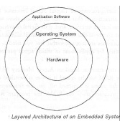
Fig 3.1.1 Layered Architecture of an Embedded System
Now, let us see the details of the various building blocks of the hardware of an embedded system. As shown in Fig. the building blocks are;
· Central Processing Unit (CPU)
· Memory (Read-only Memory and Random Access Memory)
· Input Devices
· Output devices
· Communication interfaces
· Application-specific circuitry
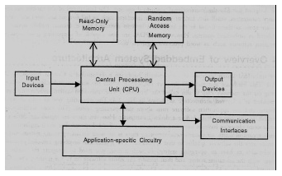
Fig 3.1.2 CPU
Central Processing Unit (CPU):
The Central Processing Unit (processor, in short) can be any of the following: microcontroller, microprocessor or Digital Signal Processor (DSP). A micro-controller is a low-cost processor. Its main attraction is that on the chip itself, there will be many other components such as memory, serial communication interface, analog-to digital converter etc. So, for small applications, a micro-controller is the best choice as the number of external components required will be very less. On the other hand, microprocessors are more powerful, but you need to use many external components with them. D5P is used mainly for applications in which signal processing is involved such as audio and video processing.
Memory:
The memory is categorized as Random Access 11emory (RAM) and Read Only Memory (ROM). The contents of the RAM will be erased if power is switched off to the chip, whereas ROM retains the contents even if the power is switched off. So, the firmware is stored in the ROM. When power is switched on, the processor reads the ROM; the program is program is executed.
Input Devices:
Unlike the desktops, the input devices to an embedded system have very limited capability. There will be no keyboard or a mouse, and hence interacting with the embedded system is no easy task. Many embedded systems will have a small keypad-you press one key to give a specific command. A keypad may be used to input only the digits. Many embedded systems used in process control do not have any input device for user interaction; they take inputs from sensors or transducers 1’fnd produce electrical signals that are in turn fed to other systems.
Output Devices:
The output devices of the embedded systems also have very limited capability. Some embedded systems will have a few Light Emitting Diodes (LEDs) to indicate the health status of the system modules, or for visual indication of alarms. A small Liquid Crystal Display (LCD) may also be used to display some important parameters.
Communication Interfaces:
The embedded systems may need to, interact with other embedded systems at they may have to transmit data to a desktop. To facilitate this, the embedded systems are provided with one or a few communication interfaces such as RS232, RS422, RS485, Universal Serial Bus (USB), IEEE 1394, Ethernet etc.
Application-Specific Circuitry:
Sensors, transducers, special processing and control circuitry may be required fat an embedded system, depending on its application. This circuitry interacts with the processor to carry out the necessary work. The entire hardware has to be given power supply either through the 230 volts main supply or through a battery. The hardware has to design in such a way that the power consumption is minimized.

3.2 BLOCK DIAGRAM

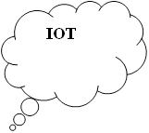

Node MCU

Power Supply
OLED
LED Indication

Buzzer
Driver
Circuit
Circuit Breaker Motor
Bluetooth

3.3 MODULES
1. POWER SUPPLY
The power supply section is the section which provide +5V for the components to work. IC LM7805 is used for providing a constant power of +5V.
The ac voltage, typically 220V, is connected to a transformer, which steps down that ac voltage down to the level of the desired dc output. A diode rectifier then provides a full-wave rectified voltage that is initially filtered by a simple capacitor filter to produce a dc voltage. This resulting dc voltage usually has some ripple or ac voltage variation.

A regulator circuit removes the ripples and also retains the same dc value even if the input dc voltage varies, or the load connected to the output dc voltage changes. This voltage regulation is usually obtained using one of the popular voltage regulator IC units.

Fig 3.3.1 Block Diagram of Power Supply

Transformer
Transformers convert AC electricity from one voltage to another with little loss of power. Transformers work only with AC and this is one of the reasons why mains electricity is AC.
Step-up transformers increase voltage, step-down transformers reduce voltage. Most power supplies use a step-down transformer to reduce the dangerously high mains voltage (230V in India) to a safer low voltage.
The input coil is called the primary and the output coil is called the secondary. There is no electrical connection between the two coils; instead they are linked by an alternating magnetic field created in the soft-iron core of the transformer. Transformers waste very little power so the power out is (almost) equal to the power in. Note that as voltage is stepped down current is stepped up.
The transformer will step down the power supply voltage (0-230V) to (0- 6V) level. Then the secondary of the potential transformer will be connected to the bridge rectifier, which is constructed with the help of PN junction diodes. The advantages of using bridge rectifier are it will give peak voltage output as DC.

Rectifier
There are several ways of connecting diodes to make a rectifier to convert AC to DC. The bridge rectifier is the most important and it produces full-wave varying DC. A full-wave rectifier can also be made from just two diodes if a centre-tap transformer is used, but this method is rarely used now that diodes are cheaper. A single diode can be used as a rectifier but it only uses the positive (+) parts of the AC wave to produce half-wave varying DC

Bridge Rectifier
When four diodes are connected as shown in figure, the circuit is called as bridge rectifier. The input to the circuit is applied to the diagonally opposite corners of the network, and the output is taken from the remaining two corners. Let us assume that the transformer is working properly and there is a positive potential, at point A and a negative potential at point B. the positive potential at point A will forward bias D3 and reverse bias D4.

Fig 3.3.2 Bridge Rectifier
The negative potential at point B will forward bias D1 and reverse D2. At this time D3 and D1 are forward biased and will allow current flow to pass through them; D4 and D2 are reverse biased and will block current flow.
One advantage of a bridge rectifier over a conventional full-wave rectifier is that with a given transformer the bridge rectifier produces a voltage output that is nearly twice that of the conventional full-wave circuit.
i. The main advantage of this bridge circuit is that it does not require a special centre tapped transformer, thereby reducing its size and cost.
ii. The single secondary winding is connected to one side of the diode bridge network and the load to the other side as shown below.
iii. The result is still a pulsating direct current but with double the frequency.

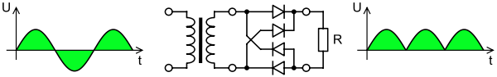
Fig 3.3.3 Output Waveform Of DC

Smoothing
Smoothing is performed by a large value electrolytic capacitor connected across the DC supply to act as a reservoir, supplying current to the output when the varying DC voltage from the rectifier is falling. The capacitor charges quickly near the peak of the varying DC, and then discharges as it supplies current to the output.

Voltage Regulators
Voltage regulators comprise a class of widely used ICs. Regulator IC units contain the circuitry for reference source, comparator amplifier, control device, and overload protection all in a single IC. IC units provide regulation of either a fixed positive voltage, a fixed negative voltage, or an adjustably set voltage. The regulators can be selected for operation with load currents from hundreds of milli amperes to tens of amperes, corresponding to power ratings from milli watts to
tens of watts.
A fixed three-terminal voltage regulator has an unregulated dc input voltage, Vi, applied to one input terminal, a regulated dc output voltage, Vo, from a second terminal, with the third terminal connected to ground.
The series 78 regulators provide fixed positive regulated voltages from 5 to 24 volts. Similarly, the series 79 regulators provide fixed negative regulated voltages from 5 to 24 volts. Voltage regulator ICs are available with fixed (typically 5, 12 and 15V) or variable output voltages. They are also rated by the maximum current they can pass. Negative voltage regulators are available, mainly for use in dual supplies. Most regulators include some automatic protection from excessive current ('overload protection') and overheating ('thermal protection').
Many of the fixed voltage regulator ICs has 3 leads and look like power transistors, such as the 7805 +5V 1Amp regulator. They include a hole for attaching a heat sink if necessary.
Fig 3.3.4 Regulator

Fig 3.3.5 Circuit Diagram Of Power Supply
2. MICROCONTROLLER
A Microcontroller (or MCU) is a computer-on-a-chip used to control electronic devices. It is a type of microprocessor emphasizing self-sufficiency and cost-effectiveness, in contrast to a general-purpose microprocessor (the kind used in a PC). A typical microcontroller contains all the memory and interfaces needed for a simple application, whereas a general-purpose microprocessor requires additional chips to provide these functions.

A microcontroller is a single integrated circuit with the following key features:
- central processing unit - ranging from small and simple 8-bit processors to sophisticated 32- or 64-bit processors
- input/output interfaces such as serial ports
- peripherals such as timers and watchdog circuits
- RAM for data storage
- ROM, EEPROM or Flash memory for program storage
- clock generator - often an oscillator for a quartz timing crystal, resonator or RC circuit

Microcontrollers are inside many kinds of electronic equipment (see embedded system). They are the vast majority of all processor chips sold. Over 50% are "simple" controllers, and another 20% are more specialized digital signal processors (DSPs) (ref?). A typical home in a developed country is likely to have only one or two general-purpose microprocessors but somewhere between one and two dozen microcontrollers. A typical mid-range vehicle has as many as 50 or more microcontrollers. They can also be found in almost any electrical device: washing machines, microwave ovens, telephones etc.

CRITERIA FOR SELECTION OF A MICROCONTROLLER IN EMBEDDED SYSTEM
Criteria for selection of microcontroller in any embedded system is as following:
(a) Meeting the computing needs of task at hand efficiently and cost effectively
• Speed of operation

• Packing

• Power consumption
• Amount of RAM and ROM on chip
• No. of I/O pins and timers on chip
• Cost
(b) Availability of software development tools such as compiler, assembler

and debugger

NodeMCU ESP8266
NodeMCU is an open-source Lua based firmware and development board specially targeted for IoT based Applications. It includes firmware that runs on the ESP8266 Wi-Fi SoC from Espressif Systems, and hardware which is based on the ESP-12 module.

NodeMCU Development Board Pinout Configuration
Pin Category | Name | Description
Power | Micro-USB, 3.3V, GND, Vin | Micro-USB: NodeMCU can be powered through the USB port  3.3V: Regulated 3.3V can be supplied to this pin to power the board  GND: Ground pins  Vin: External Power Supply
Control Pins | EN, RST | The pin and the button resets the microcontroller
Analog Pin | A0 | Used to measure analog voltage in the range of 0-3.3V
GPIO Pins | GPIO1 to GPIO16 | NodeMCU has 16 general purpose input-output pins on its board
SPI Pins | SD1, CMD, SD0, CLK | NodeMCU has four pins available for SPI communication.
UART Pins | TXD0, RXD0, TXD2, RXD2 | NodeMCU has two UART interfaces, UART0 (RXD0 & TXD0) and UART1 (RXD1 & TXD1). UART1 is used to upload the firmware/program.
I2C Pins |  | NodeMCU has I2C functionality support but due to the internal functionality of these pins, you have to find which pin is I2C.
Table 3.3.1 NodeMCU Development Board Pinout Configuration
NodeMCU ESP8266 Specifications & Features
- Microcontroller: Tensilica 32-bit RISC CPU Xtensa LX106
- Operating Voltage: 3.3V
- Input Voltage: 7-12V
- Digital I/O Pins (DIO): 16
- Analog Input Pins (ADC): 1
- UARTs: 1
- SPIs: 1
- I2Cs: 1
- Flash Memory: 4 MB
- SRAM: 64 KB
- Clock Speed: 80 MHz
- USB-TTL based on CP2102 is included onboard, Enabling Plug n Play
- PCB Antenna
- Small Sized module to fit smartly inside your IoT projects

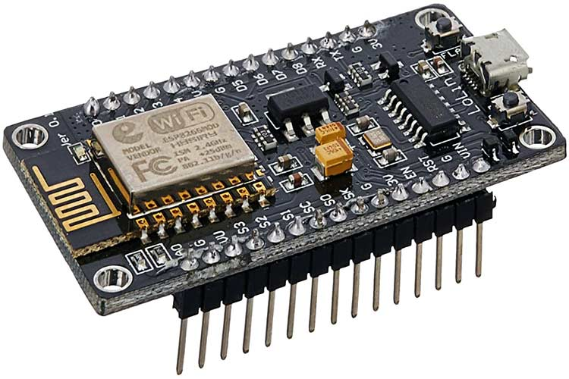
Fig 3.4 ESP8266 NodeMCU

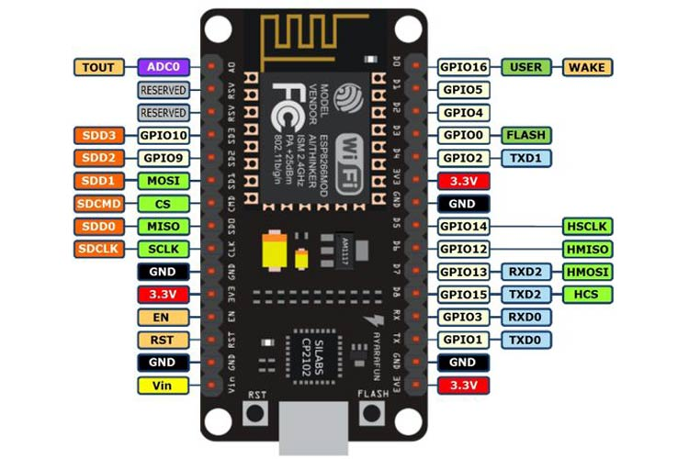
Fig 3.5 NodeMCU ESP8266 Pinout

General Purpose Input/Output Interface (GPIO)
ESP8266EX has 17 GPIO pins which can be assigned to various functions by programming the appropriate registers.
Each GPIO can be configured with internal pull-up or pull-down, or set to high impedance, and when configured as an input, the data are stored in software registers; the input can also be set to edge-trigger or level trigger CPU interrupts. In short, the IO pads are bi-directional, non-inverting and tristate, which includes input and output buffer with tristate control inputs.
These pins can be multiplexed with other functions such as I2C, I2S, UART, PWM, IR Remote Control, etc.

Secure Digital Input/Output Interface (SDIO)
ESP8266EX has one Slave SDIO, the definitions of which are described below. 4-bit 25 MHz SDIO v1.1 and 4-bit 50 MHz SDIO v2.0 are supported.
Pin Name Pin Num IO Function Name
SDIO_CLK 21 IO6 SDIO_CLK
SDIO_DATA0 22 IO7 SDIO_DATA0
SDIO_DATA1 23 IO8 SDIO_DATA1
SDIO_DATA_2 18 IO9 SDIO_DATA_2
SDIO_DATA_3 19 IO10 SDIO_DATA_3
SDIO_CMD 20 IO11 SDIO_CMD

Serial Peripheral Interface (SPI/HSPI)
ESP8266EX has 3 SPIs.
One general Slave/Master SPI
One Slave SDIO/SPI
One general Slave/Master HSPI
Functions of all these pins can be implemented via hardware. The pin definitions are described as below.

General SPI (Master/Slave)
Pin Name Pin Num IO Function Name
SDIO_CLK 21 IO6 SPICLK
SDIO_DATA0 22 IO7 SPIQ/MISO
SDIO_DATA1 23 IO8 SPID/MOSI
SDIO_DATA_2 18 IO9 SPIHD
SDIO_DATA_3 19 IO10 SPIWP
U0TXD 26 IO1 SPICS1
GPIO0 15 IO0 SPICS2

I2C Interface
ESP8266EX has one I2C used to connect with micro-controller and other peripheral equipments such as sensors. The pin definition of I2C is as below.

Pin Name Pin Num IO Function Name
MTMS 9 IO14 I2C_SCL
GPIO2 14 IO2 I2C_SDA

Both I2C Master and I2C Slave are supported. I2C interface functionality can be realized via software programming, the clock frequency reaches 100 kHz at a maximum. It should be noted that I2C clock frequency should be higher than the slowest clock frequency of the slave device.

I2S Interface
ESP8266EX has one I2S data input interface and one I2S data output interface. I2S interfaces are mainly used in applications such as data collection, processing, and transmission of audio data, as well as the input and output of serial data. For example, LED lights (WS2812 series) are supported. The pin definition of I2S is as below. I2S functionality can be enabled via software programming by using multiplexed GPIOs, and linked list DMA is supported.

I2S Data Input
Pin Name Pin Num IO Function Name
MTDI 10 IO12 I2SI_DATA
MTCK 12 IO13 I2SI_BCK
MTMS 9 IO14 I2SI_WS
MTDO 13 IO15 I2SO_BCK
U0RXD 25 IO3 I2SO_DATA
GPIO2 14 IO2 I2SO_WS

Universal Asynchronous Receiver Transmitter (UART)
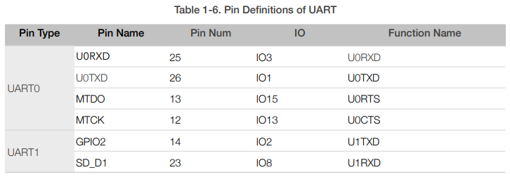
ESP8266EX has two UART interfaces UART0 and UART, the definitions are as below.

Data transfers to/from UART interfaces can be implemented via hardware. The data transmission speed via UART interfaces reaches 115200 x 40 (4.5 Mbps).
UART0 can be used for communication. It supports fluid control. Since UART1 features only data transmit signal (Tx), it is usually used for printing log.

Pulse-Width Modulation (PWM)
ESP8266EX has four PWM output interfaces. They can be extended by users themselves.
The pin definitions of the PWM interfaces are defined as below.
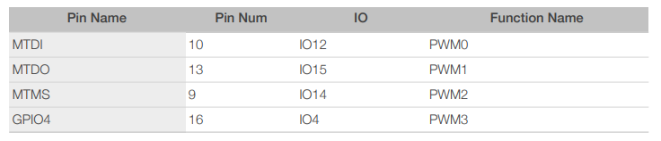

The functionality of PWM interfaces can be implemented via software programming. For example, in the LED smart light demo, the function of PWM is realized by interruption of the timer, the minimum resolution reaches as much as 44 ns. PWM frequency range is adjustable from 1000 μs to 10000 μs, i.e., between 100Hz and 1 kHz. When the PWM frequency is 1 kHz, the duty ratio will be 1/22727, and over 14 bit resolution will be achieved at 1 kHz refresh rate.

IR Remote Control
One Infrared remote-control interface is defined as below.
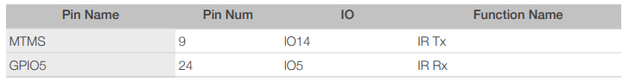

The functionality of Infrared remote-control interface can be implemented via software programming. NEC coding, modulation, and demodulation are used by this interface. The frequency of modulated carrier signal is 38 kHz, while the duty ratio of the square wave is 1/3. The transmission range is around 1m which is determined by two factors: one is the maximum value of rated current, the other is internal current-limiting resistance value in the infrared receiver. The larger the resistance value, the lower the current, so is the power, and vice versa. The transmission angle is between 15° and 30° which is determined by the radiation direction of the infrared receiver.
Instruction on GPIO Registers
GPIO Function Selection Register
The ESP8266 MTDI is used to demonstrate the GPIO function selection.
Function selection register PERIPHS_IO_MUX_MTDI_U (this register differs for different GPIOs)
PIN_FUNC_SELECT(PERIPHS_IO_MUX_MTDI_U,FUNC_GPIO12);
FUNC_GPIO12=3.
Configurations differ for different pins.

GPIO Output Registers
• Output enable register: GPIO_ENABLE_W1TS
bit[15:0] the output enable bit (readable and writable):
If the related bit is set to be 1, the IO output is enabled. Bit[15:0] contains 16 GPIO output enable bits.

• Output disable register: GPIO_ENABLE_W1TC
bit[15:0] the output disable bit (readable and writable):
If the related bit is set to be 1, the IO output is disabled. Bit[15:0] contains 16 GPIO output disable bits.

• Output enable status register: GPIO_ENABLE
bit[15:0] the output enable status bit (readable and writable):
Value of bit[15:0] of this register shows the related pin output enable status.
By writing data into bit[15:0] of GPIO_ENABLE_W1TS and bit[15:0] of
GPIO_ENABLE_W1TC, users can control bit[15:0] of GPIO_ENABLE. For example, when bit[0] of GPIO_ENABLE_W1T is set to be 1, then bit[0] of GPIO_ENABLE =1; when bit[1] of GPIO_ENABLE_W1TC is set to be 1, then bit[1] of GPIO_ENABLE = 0.

• Output low level register GPIO_OUT_W1TC
bit[15:0] output low level bit (write only register):
If the related bit is set to be 1, the IO output is low level (at the same time, users should enable the output). Bit[15:0] contains 16 GPIO output statuses.

• Output high level register GPIO_OUT_W1TS
bit[15:0] output high level bit (write only register):
If the related bit is set to be 1, it means the IO output is high level (at the same time, users should enable the output). Bit[15:0] contains 16 GPIO output statuses.

• Output high level register GPIO_OUT_W1TS
bit[15:0] output high level bit (write only register):
If the related bit is set to be 1, it means the IO output is high level (at the same time, users should enable the output). Bit[15:0] contains 16 GPIO output statuses.

GPIO Input Register
bit[15:0] the input status bit (readable and writable):
If the related bit is set to be 1, the IO pin status is high level. If the related bit is set to be 0, the IO pin status is low level. Bit[15:0] contains 16 GPIO input status bits.

GPIO Interrupt Registers
• Interrupt type register GPIO_PIN12 (this register differs for different GPIOs)
Bit [9:7] (readable and writable):
0: the GPIO interrupt is disabled
1: rising edge triggered interrupt
2: falling edge triggered interrupt
3: double-edge triggered interrupt
4: low level
5: high level
• Interrupt status register GPIO_STATUS
Bit[15:0] (readable and writable):
If the related bit is set to be 1, the IO interrupts. Bit[15:0] contains 16 GPIOs.
• Interrupt clearing register GPIO_STATUS_W1TC
Bit[15:0] (readable and writable):
Write 1 into the related bit, the related GPIO interrupt status will be cleared.

GPIO16 Related APIs
Different from other IO interfaces, GPIO16(XPD_DCDC) belongs to the RTC module instead of the general GPIO module. It can be used to wake up the chip during deep-sleep; it can be configured to input or output mode; but it cannot trigger the IO interrupt. the APIs are shown below.
• gpio16_output_conf(void)
Set the GPIO16 to the output mode.
• gpio16_output_set(uint8 value)
Output high/low level from GPIO16. Configure GPIO16 to the output mode first.
• gpio16_input_conf(void)
Set the GPIO16 to the input mode.
• gpio16_input_get(void)
Read the GPIO16 input level status. Configure GPIO16 to the input mode first.

Install the ESP8266 Board Package
Enter http://arduino.esp8266.com/stable/package_esp8266com_index.json into Additional Board Manager URLsfield in the Arduino v1.6.4+ preferences.

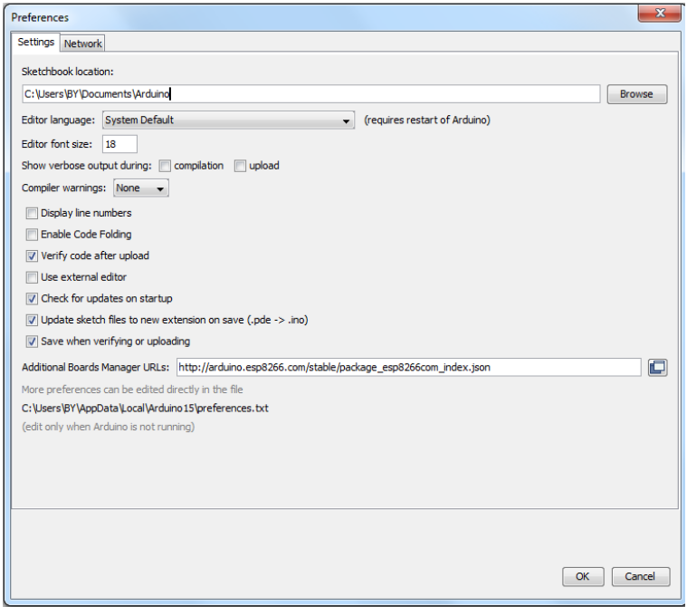
Click ‘File’ -> ‘Preferences’ to access this panel.
Next, use the Board manager to install the ESP8266 package.

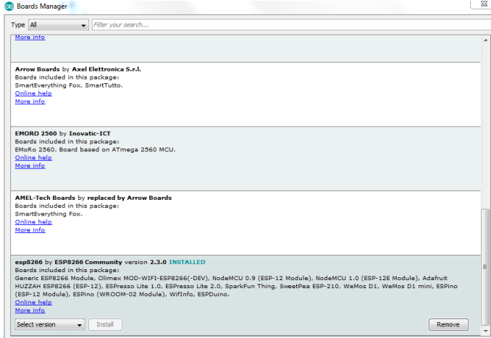
Click ‘Tools’ -> ‘Board:’ -> ‘Board Manager…’ to access this panel.
Scroll down to ‘esp8266 by ESP8266 Community’ and click “Install” button to install the ESP8266 library package.
Once installation completed, close and re-open Arduino IDE for ESP8266 library to take effect.

Setup ESP8266 Support
When you've restarted Arduino IDE, select ‘Generic ESP8266 Module’ from the ‘Tools’ -> ‘Board:’ dropdown menu.
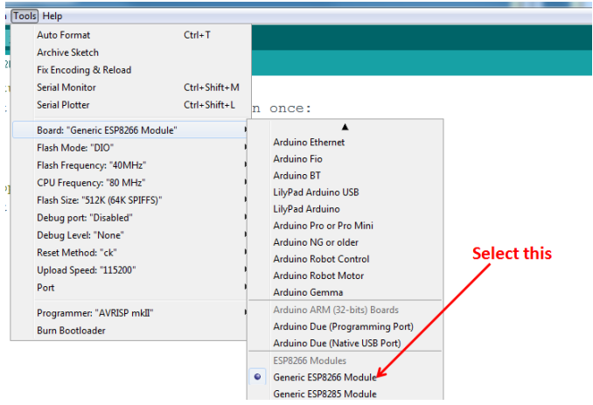
Select 80 MHz as the CPU frequency (you can try 160 MHz overclock later)
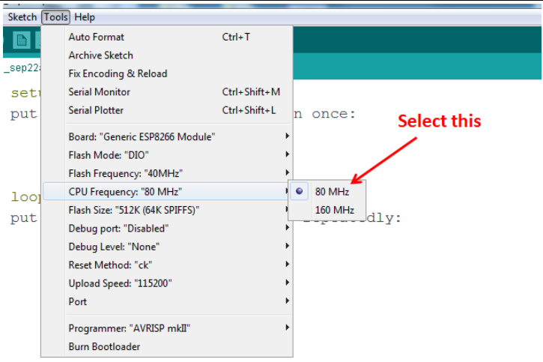
Select ‘115200’ baud upload speed is a good place to start - later on you can try higher speeds but 115200 is a good safe place to start.
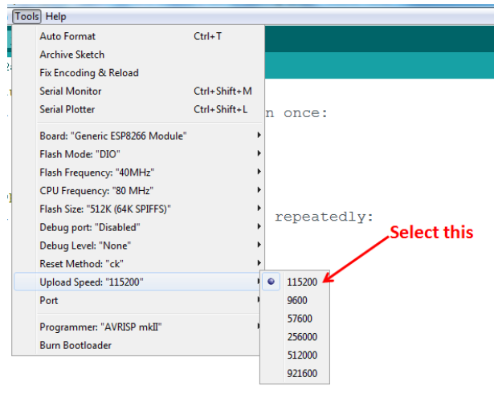
Go to your Windows ‘Device Manager’ to find out which Com Port ‘USB-Serial CH340’ is assigned to. Select the matching COM/serial port for your CH340 USB-Serial interface.

3. OLED (Organic Light Emitting Diodes)
OLED (Organic Light Emitting Diodes) is a flat light emitting technology, made by placing a series of organic thin films between two conductors. When electrical current is applied, a bright light is emitted. OLEDs are emissive displays that do not require a backlight and so are thinner and more efficient than LCD displays (which do require a white backlight).
OLED displays are not just thin and efficient - they provide the best image quality ever and they can also be made transparent, flexible, foldable and even rollable and stretchable in the future. OLEDs represent the future of display technology!

OLED vs LCD
An OLED display have the following advantages over an LCD display:
- Improved image quality - better contrast, higher brightness, fuller viewing angle, a wider color range and much faster refresh rates.
- Lower power consumption.
- Simpler design that enables ultra-thin, flexible, foldable and transparent displays
- Better durability - OLEDs are very durable and can operate in a broader temperature range
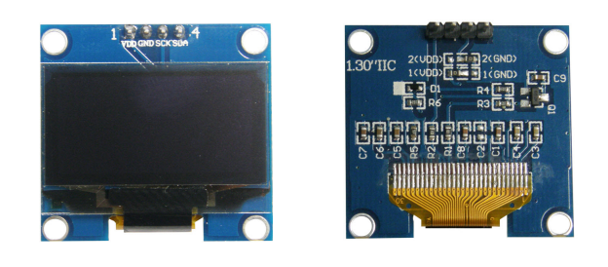

The future - flexible and transparent OLED displays
As we said, OLEDs can be used to create flexible and transparent displays. This is pretty exciting as it opens up a whole world of possibilities:
- Curved OLED displays, placed on non-flat surfaces
- Wearable OLEDs
- Foldable OLEDs and rollable OLEDs which can be used to create new mobile devices
- Transparent OLEDs embedded in windows or car windshdields
- And many more we cannot even imagine today...
Flexible OLEDs are already on the market for many years (in smartphones, wearables and other devices) and since 2019, with the introduction of the Samsung Galaxy Fold, foldable devices are increasing in popularity. In 2019 LG also announced the world's first rollable OLED - its 65" OLED R TV that can roll into its base!
An OLED is made by placing a series of organic thin films between two conductors. When electrical current is applied, a bright light is emitted. Click here for a more detailed view of the OLED technology.
OLEDs are organic because they are made from carbon and hydrogen. There's no connection to organic food or farming - although OLEDs are very efficient and do not contain any bad metals - so it's a real green technology.
OLED is the best display technology - and indeed OLED panels are used today to create the most stunning TVs ever - with the best image quality combined with the thinnest sets ever. And this is only the beginning, as in the future OLED will enable large rollable and transparent TVs!
Currently the only company that produces OLED TV panels is LG Display. The Korean display maker is producing a wide range of OLED TV panels, offering these to LG Electronics, Panasonic, Sony, Philips and others.

OLED white lighting
OLEDs can be used to create excellent light source. OLEDs offer diffuse area lighting and can be flexible, efficient, light, thin, transparent, color-tunable and more. OLEDs enable new designs and these devices emit healthier light compared to CFLs and LED lighting devices.

Specifications
- Use CHIP No.SH1106
- Use 3.3V-5V POWER SUPPLY
- Graphic LCD 1.3” in width with 128x64 Dot Resolution
- White Display is used for the model OLED 1.3 I2C WHITE and blue Display is used for the model OLED 1.3 I2C BLUE
- Use I2C Interface
- Directly connect signal to Microcontroller 3.3V and 5V without connecting through Voltage Regulator Circuit
- Total Current when running together is 8 mA - PCB Size: 33.7 mm x 35.5 mm

Table shows name and function of Pin OLED
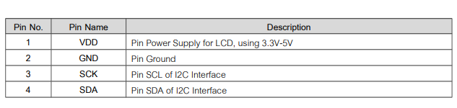
Table 3.3.2 Function of pin OLED
Example of connecting with Board Arduino This example illustrates how to connect together with Board Arduino, in this case, it is Board ET-BASE AVR EASY328. It is used together with Program Arduino and Library to connect and communicate to Module OLED. - Firstly, install Library“u8glib”; go to Menu Sketch > Include Library > Add.ZIP Library...
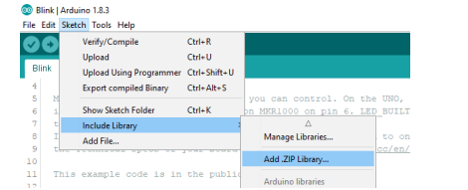
- Go to Folder Lib_Arduino\u8glib in CD-ROM; next, choose hown in the picturebelow.
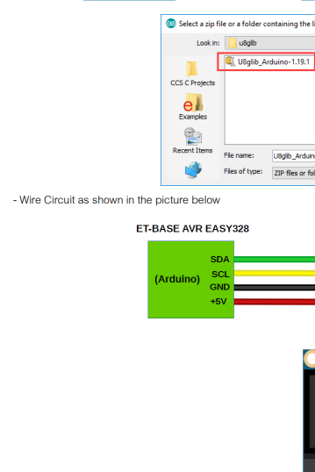

4. Internet of things (IoT)
Internet of things (IoT), is another advance technology in IT sector, provides internetworking for numerous of devices such as sensors, actuators, PLCs and other electronic embedded smart devices and controls, and various software’s’ and provides systems network configuration and connectivity, which enables communication between these numerous devices for information exchanging.
In 1995, “thing to thing” was coined by BILL GATES. In 1999, IoT (Internet of Things) was come up by EPC global. IOT interconnects human to thing, thing to thing and human to human. The goal of IoT is bring out a huge network by combining different types connected devices. IoT targets three aspects Communication, automation, cost saving in a system. IOT empowers people to carry out routine activities using internet and thus saves time and cost making them more productive. IOT enables the objects to be sensed and/or controlled remotely across existing network model. IOT in environmental monitoring helps to know about the air and water quality, temperature and conditions of the soil, and also monitor the intrusion of animals in to the field. IOT can also play a significant role in precision farming to enhance the productivity of the farm.
Recent advancements, such as the vision of the Internet of Things (IoT), the cloud computing model, and cyber-physical systems, provide support for the transmission and management of huge amounts of data regarding the trends observed in environmental parameters. In this context, the current work presents three different IoT-based wireless sensors
for environmental and ambient monitoring: one employing User Datagram Protocol (UDP)-based Wi-Fi communication, one communicating through Wi-Fi and Hypertext Transfer Protocol (HTTP), and a third one using Bluetooth Smart. All of the presented systems provide the possibility of recording data at remote locations and of visualizing them from every device with an Internet connection, enabling the monitoring of geographically large areas. The development details of these systems are described, along with the major differences and similarities between them. The feasibility of the three developed systems for implementing monitoring applications, taking into account their energy autonomy, ease of use, solution complexity, and Internet connectivity facility, was analysed, and revealed that they make good candidates for IoT-based solutions.
Nowadays, IoT is one of the most advanced, efficient, and cost less technological solution which encompasses various hardware and software resources; and allows remotely connected sensing devices to sense with more capabilities, provides efficiency and can be monitored and controlled through deployed of existing systems or infrastructures, resulting the physical World integration with computer controllers (or systems).
As IoT provides interconnectivity among various real-time sensing sensors and PLC and other intelligent devices, therefore this technology will be an entity indicated for the more advance cyber-systems encircling the significant developments, “such as smart grid, smart vehicle systems, smart medical systems, smart cities, and others smart systems.” In early future, IoT has striven to provide advance or smart connectivity for variety of electronic and intelligent equipment’s or devices, IT-based systems and the more advanced services through deploying of various traditional and real-time protocols, networks domains, and system software/hardware applications, which will be an work followed by machine-to-machine technological concept.
Through interconnection of various devices and managing ofThe internet of things (IoT) is the network of physical devices, vehicles, buildings and other items embedded with electronics, software, sensors, actuators, and network connectivity that enable these objects to collect and exchange data. In 2013 the Global Standards Initiative on Internet of Things (IoT-GSI) defined the IoT as "the infrastructure of the information society. The IoT allows objects to be sensed and controlled remotely across existing network infrastructure, creating opportunities for more direct integration of the physical world into computer-based systems, and resulting in improved efficiency, accuracy and economic benefit.
When IoT is augmented with sensors and actuators, the technology becomes an instance of the more general class of cyber-physical systems, which also encompasses technologies such as smart grids, smart homes, intelligent transportation and smart cities. Each thing is uniquely identifiable through its embedded computing system but is able to interoperate within the existing Internet infrastructure. Experts estimate that the IoT will consist of almost 50 billion objects by 2020.
IoT is a system defines an environment that encompasses numerous of objects; sensors that connected with these objects are accessible over the Internet through employing of various
Networks connections, such wired or wireless. IoT can be able to carry information from various embedded sensors attached with the physical World, human and any inanimate object, and then transmit them to a system for further analyses. In early future, IoT will be able to connect almost components or parts of industrial infrastructures, smart medical tele monitoring systems, and smart transportation systems; and will provide the information sharing facilities in order to make systems and peoples always updated.
What is the internet of things (IoT)?
The internet of things, or IoT, is a system of interrelated computing devices, mechanical and digital machines, objects, animals or people that are provided with unique identifiers (UIDs) and the ability to transfer data over a network without requiring human-to-human or human-to-computer interaction.
A thing in the internet of things can be a person with a heart monitor implant, a farm animal with a biochip transponder, an automobile that has built-in sensors to alert the driver when tire pressure is low or any other natural or man-made object that can be assigned an Internet Protocol (IP) address and is able to transfer data over a network.
Increasingly, organizations in a variety of industries are using IoT to operate more efficiently, better understand customers to deliver enhanced customer service, improve decision-making and increase the value of the business.

How does IoT work?
An IoT ecosystem consists of web-enabled smart devices that use embedded systems, such as processors, sensors and communication hardware, to collect, send and act on data they acquire from their environments. IoT devices share the sensor data they collect by connecting to an IoT gateway or other edge device where data is either sent to the cloud to be analyzed or analyzed locally. Sometimes, these devices communicate with other related devices and act on the information they get from one another. The devices do most of the work without human intervention, although people can interact with the devices -- for instance, to set them up, give them instructions or access the data.
The connectivity, networking and communication protocols used with these web-enabled devices largely depend on the specific IoT applications deployed.
IoT can also make use of artificial intelligence (AI) and machine learning to aid in making data collecting processes easier and more dynamic.

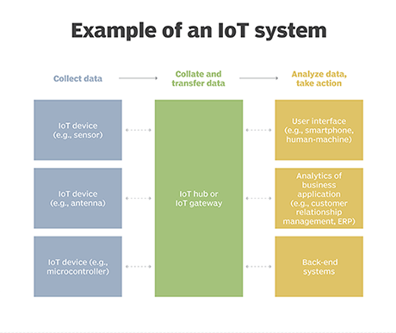
Why is IoT important?
The internet of things helps people live and work smarter, as well as gain complete control over their lives. In addition to offering smart devices to automate homes, IoT is essential to business. IoT provides businesses with a real-time look into how their systems really work, delivering insights into everything from the performance of machines to supply chain and logistics operations.
IoT enables companies to automate processes and reduce labor costs. It also cuts down on waste and improves service delivery, making it less expensive to manufacture and deliver goods, as well as offering transparency into customer transactions.
As such, IoT is one of the most important technologies of everyday life, and it will continue to pick up steam as more businesses realize the potential of connected devices to keep them competitive.
What are the benefits of IoT to organizations?
The internet of things offers several benefits to organizations. Some benefits are industry-specific, and some are applicable across multiple industries. Some of the common benefits of IoT enable businesses to:
- monitor their overall business processes;
- improve the customer experience (CX);
- save time and money;
- enhance employee productivity;
- integrate and adapt business models;
- make better business decisions; and
- generate more revenue.
IoT encourages companies to rethink the ways they approach their businesses and gives them the tools to improve their business strategies.
Generally, IoT is most abundant in manufacturing, transportation and utility organizations, making use of sensors and other IoT devices; however, it has also found use cases for organizations within the agriculture, infrastructure and home automation industries, leading some organizations toward digital transformation.
IoT can benefit farmers in agriculture by making their job easier. Sensors can collect data on rainfall, humidity, temperature and soil content, as well as other factors, that would help automate farming techniques.
The ability to monitor operations surrounding infrastructure is also a factor that IoT can help with. Sensors, for example, could be used to monitor events or changes within structural buildings, bridges and other infrastructure. This brings benefits with it, such as cost saving, saved time, quality-of-life workflow changes and paperless workflow.
A home automation business can utilize IoT to monitor and manipulate mechanical and electrical systems in a building. On a broader scale, smart cities can help citizens reduce waste and energy consumption.
IoT touches every industry, including businesses within healthcare, finance, retail and manufacturing.

What are the pros and cons of IoT?
Some of the advantages of IoT include the following:
- ability to access information from anywhere at any time on any device;
- improved communication between connected electronic devices;
- transferring data packets over a connected network saving time and money; and
- automating tasks helping to improve the quality of a business's services and reducing the need for human intervention.
Some disadvantages of IoT include the following:
- As the number of connected devices increases and more information is shared between devices, the potential that a hacker could steal confidential information also increases.
- Enterprises may eventually have to deal with massive numbers -- maybe even millions -- of IoT devices, and collecting and managing the data from all those devices will be challenging.
- If there's a bug in the system, it's likely that every connected device will become corrupted.
- Since there's no international standard of compatibility for IoT, it's difficult for devices from different manufacturers to communicate with each other.

IoT standards and frameworks
There are several emerging IoT standards, including the following:
- IPv6 over Low-Power Wireless Personal Area Networks (6LoWPAN) is an open standard defined by the Internet Engineering Task Force (IETF). The 6LoWPAN standard enables any low-power radio to communicate to the internet, including 804.15.4, Bluetooth Low Energy (BLE) and Z-Wave (for home automation).
- ZigBee is a low-power, low-data rate wireless network used mainly in industrial settings. ZigBee is based on the Institute of Electrical and Electronics Engineers (IEEE) 802.15.4 standard. The ZigBee Alliance created Dotdot, the universal language for IoT that enables smart objects to work securely on any network and understand each other.
- LiteOS is a Unix-like operating system (OS) for wireless sensor networks. LiteOS supports smartphones, wearables, intelligent manufacturing applications, smart homes and the internet of vehicles (IoV). The OS also serves as a smart device development platform.
- OneM2M is a machine-to-machine service layer that can be embedded in software and hardware to connect devices. The global standardization body, OneM2M, was created to develop reusable standards to enable IoT applications across different verticals to communicate.
- Data Distribution Service (DDS) was developed by the Object Management Group (OMG) and is an IoT standard for real-time, scalable and high-performance M2M communication.
- Advanced Message Queuing Protocol (AMQP) is an open source published standard for asynchronous messaging by wire. AMQP enables encrypted and interoperable messaging between organizations and applications. The protocol is used in client-server messaging and in IoT device management.
- Constrained Application Protocol (CoAP) is a protocol designed by the IETF that specifies how low-power, compute-constrained devices can operate in the internet of things.
- Long Range Wide Area Network (LoRaWAN) is a protocol for WANs designed to support huge networks, such as smart cities, with millions of low-power devices.

IoT frameworks include the following:
- Amazon Web Services (AWS) IoT is a cloud computing platform for IoT released by Amazon. This framework is designed to enable smart devices to easily connect and securely interact with the AWS cloud and other connected devices.
- Arm Mbed IoT is a platform to develop apps for IoT based on Arm microcontrollers. The goal of the Arm Mbed IoT platform is to provide a scalable, connected and secure environment for IoT devices by integrating Mbed tools and services.
- Microsoft's Azure IoT Suite is a platform that consists of a set of services that enables users to interact with and receive data from their IoT devices, as well as perform various operations over data, such as multidimensional analysis, transformation and aggregation, and visualize those operations in a way that's suitable for business.
- Google's Brillo/Weave is a platform for the rapid implementation of IoT applications. The platform consists of two main backbones: Brillo, an Android-based OS for the development of embedded low-power devices, and Weave, an IoT-oriented communication protocol that serves as the communication language between the device and the cloud.
- Calvin is an open source IoT platform released by Ericsson designed for building and managing distributed applications that enable devices to talk to each other. Calvin includes a development framework for application developers, as well as a runtime environment for handling the running application.

Consumer and enterprise IoT applications
There are numerous real-world applications of the internet of things, ranging from consumer IoT and enterprise IoT to manufacturing and industrial IoT (IIoT). IoT applications span numerous verticals, including automotive, telecom and energy.
In the consumer segment, for example, smart homes that are equipped with smart thermostats, smart appliances and connected heating, lighting and electronic devices can be controlled remotely via computers and smartphones.
Wearable devices with sensors and software can collect and analyze user data, sending messages to other technologies about the users with the aim of making users' lives easier and more comfortable. Wearable devices are also used for public safety -- for example, improving first responders' response times during emergencies by providing optimized routes to a location or by tracking construction workers' or firefighters' vital signs at life-threatening sites.
In healthcare, IoT offers many benefits, including the ability to monitor patients more closely using an analysis of the data that's generated. Hospitals often use IoT systems to complete tasks such as inventory management for both pharmaceuticals and medical instruments.
Smart buildings can, for instance, reduce energy costs using sensors that detect how many occupants are in a room. The temperature can adjust automatically -- for example, turning the air conditioner on if sensors detect a conference room is full or turning the heat down if everyone in the office has gone home.
In agriculture, IoT-based smart farming systems can help monitor, for instance, light, temperature, humidity and soil moisture of crop fields using connected sensors. IoT is also instrumental in automating irrigation systems.
In a smart city, IoT sensors and deployments, such as smart streetlights and smart meters, can help alleviate traffic, conserve energy, monitor and address environmental concerns, and improve sanitation.

IoT security and privacy issues
The internet of things connects billions of devices to the internet and involves the use of billions of data points, all of which need to be secured. Due to its expanded attack surface, IoT security and IoT privacy are cited as major concerns.
In 2016, one of the most notorious recent IoT attacks was Mirai, a botnet that infiltrated domain name server provider Dyn and took down many websites for an extended period of time in one of the biggest distributed denial-of-service (DDoS) attacks ever seen. Attackers gained access to the network by exploiting poorly secured IoT devices.
Because IoT devices are closely connected, all a hacker has to do is exploit one vulnerability to manipulate all the data, rendering it unusable. Manufacturers that don't update their devices regularly -- or at all -- leave them vulnerable to cybercriminals.
Additionally, connected devices often ask users to input their personal information, including names, ages, addresses, phone numbers and even social media accounts -- information that's invaluable to hackers.
Hackers aren't the only threat to the internet of things; privacy is another major concern for IoT users. For instance, companies that make and distribute consumer IoT devices could use those devices to obtain and sell users' personal data.
Beyond leaking personal data, IoT poses a risk to critical infrastructure, including electricity, transportation and financial services.

5. BUZZER
A buzzer or beeper is a signaling device, usually electronic, typically used in automobiles, house hold appliances such as a microwave oven, or game shows.
It most commonly consists of a number of switches or sensors connected to a control unit that determines if and which button was pushed or a preset time has lapsed, and usually illuminates a light on the appropriate button or control panel, and sounds a warning in the form of a continuous or intermittent buzzing or beeping sound. Initially this device was based on an electromechanical system which was identical to an electric bell without the metal gong (which makes the ringing noise). Often these units were anchored to a wall or ceiling and used the ceiling or wall as a sounding board. Another implementation with some AC-connected devices was to implement a circuit to make the AC current into a noise loud enough to drive a loudspeaker and hook this circuit up to a cheap 8-ohm speaker. Nowadays, it is more popular to use a ceramic-based piezoelectric sounder like a Sonalert which makes a high-pitched tone. Usually these were hooked up to “driver” circuits which varied the pitch of the sound or pulsed the sound on and off.
In game shows it is also known as a “lockout system,” because when one person signals (“buzzes in”), all others are locked out from signaling. Several game shows have large buzzer buttons which are identified as “plungers”.
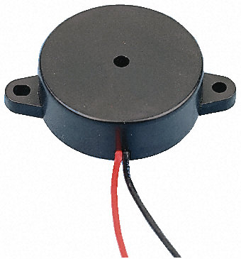
Fig 3.6 Buzzer
USES
- Annunciator panels
- Electronic metronomes
- Game shows
- Microwave ovens and other household appliances
- Sporting events such as basketball games
- Electrical alarm

6. BLUETOOTH
Bluetooth is a wireless technology standard for exchanging data over short distances (using short-wavelength UHF radio waves in the ISM band from 2.4 to 2.485 GHz) from fixed and mobile devices and building personal area networks (PANs). In 1994 a group of engineers at Ericsson, a Swedish company, invented a wireless communication technology, later called Bluetooth. In 1998, the original group of Promoter companies—Ericsson, Intel, Nokia, Toshiba and IBM—came together to form the Bluetooth Special Interest Group (SIG).
Bluetooth networking transmits data via low-power radio waves. It communicates on a frequency of 2.45 gigahertz (actually between 2.402 GHz and 2.480 GHz, to be exact). This frequency band has been set aside by international agreement for the use of industrial, scientific and medical devices (ISM). By comparison, the most powerful cell phones can transmit a signal of 3 watts. The low power limits the range of a Bluetooth device to about 10 meters (32 feet), cutting the chances of interference between your computer system and your portable telephone or television.

Some specification of Bluetooth
• Operates in the 2.4 GHZ band which is globally available
• It has 79 channels
• Uses FHSS, GFSK modulation
• 1600 hops per second
• Can support up to 8 devices in a piconet
• Omni-directional, non-line of sight transmission through walls
• 10m to 100m range
• Low cost, $20
• 1mW power
• Extended range with external power amplifier (100 meters)

Difference
There are many other wireless communication techniques are available in the market like IEEE 802.11 (Wi-Fi), IrDA, GSM, GPRS etc. But still Bluetooth is very popular among them. There are many reasons like some techniques required huge infrastructure like GSM, GPRS etc. and also they are not suitable for Adhoc networks like Bluetooth. But some wireless communications techniques are there that are the competitors of Bluetooth. Some main competitors are IEEE 802.11 and IrDA (Infrared Data Association). In this section we will discuss the differences b/w these and Bluetooth.
• IEEE 802.11
It is a family of IEEE standards for wireless LANs that were designed to extend 802.3 (wired Ethernet) into the wireless domain. The 802.11 standard is more widely known as "Wi-Fi". Based on the Bluetooth Specification, is now an IEEE standard under the denomination of 802.15 WPANs
The first 802.11 specifications were introduced in 1997 and included two spread spectrum methods for transmission in the unlicensed 2.4GHz band: 1 Mbps frequency hopping (FHSS) and 1 and 2 Mbps direct sequence (DSSS).
11b
In 1999, 802.11b boosted speed to 11 Mbps using DSSS. The 1 and 2 Mbps DSSS modes are still valid, and devices can throttle down to the lower speeds to maintain a connection when signals are weak.
An 802.11 system works in two modes. In "infrastructure" mode, wireless devices communicate to a wired LAN via base stations known as "access points." Each access point and its wireless devices are known as a Basic Service Set (BSS). An Extended Service Set (ESS) is two or more BSSs in the same subnet.
In "ad hoc" mode, also known as "peer-to-peer" mode, wireless devices communicate with each other directly without an access point. This is an Independent BSS (IBSS).
 | Peak Data Rate | Range | Relative Cost | Voice network support | Data network support
IEEE  802.11 | 2 Mbps | 50m | Medium | Via IP | TCP / IP
IrDA | 16 Mbps | < 2m | Low | Via IP | Via PPP
Bluetooth | 1 Mbps | < 10m | Medium | Via IP and cellular | Via PPP
HomeRF | 1.6 Mbps | 50m | Medium | Via IP and PSTN | TCP / IP

Communication
A Bluetooth transceiver is a frequency hopping spread-spectrum (FHSS) device that uses the unlicensed (worldwide) 2.4 GHz ISM (Industrial, Scientific, Medical) frequency band. In most countries, there are 79 channels available. The nominal bandwidth for each channel is 1MHz. When connected to other Bluetooth devices, a Bluetooth device hops (changes frequencies) at the rate of 1600 times per second for typical use, with a residence time of 625 µsec.
When in inquiry or page mode, it hops at 3200 hops per second with a residence time of 312.5 µsec. A Bluetooth transceiver uses all 79 channels, and hops pseudo-randomly across all channels at a rate of 1600 hops per second for standard transmissions. It has a range of approximately10 meters, although ranges up to 100 meters can be achieved with amplifiers. Because the transceiver has an extremely small footprint, it is easily embedded into physical devices, making it a truly ubiquitous radio link. The Bluetooth specification uses time division duplexing (TDD) and time division multiple access (TDMA) for device communication.
A single time slot is 625 µ sec in length, representing the length of a single-slot packet. At the Baseband layer, a packet consists of an access code, a header, and the payload, as shown in Fig. 3. The access code contains the piconet address (to filter out messages from other piconets) and is usually 72 bits in length. The header contains link control data, encoded with a forward error-correcting code (FEC) with a 1/3 rate for high reliability. Such code is a repetition code and thus every bit in the header is transmitted three times. The header is usually 18 bits in length, and includes the active member address for a currently active slave.
The payload can contain from 0 to 2745 bits of data, and may be protected by a 1/3 rate FEC (simple bit repetition, for SCO packets only), a 2/3 rate FEC (which is a (15,10) shortened Hamming code capable of correcting all one-bit errors and detecting all two-bit errors), or a 3/3/ rate (no FEC). For SCO connections, packets must be exactly one time-slot in length. For ACL links, packets may be 1, 3, or 5 time slots in length. Bluetooth uses polling-based packet transmission. All communication between devices takes place between a master and a slave, using time-division duplex (TDD), with no direct slave-to slave communication.
The master will poll each active slave to determine if it has data to transmit. The slave may only transmit data when it has been polled. Also, it must send its data in the time slot immediately following the one in which it was polled. The master transmits only in even numbered time slots, while the slaves transmit only in odd-numbered time slots. In each time slot, a different frequency channel f is used (a hop in the hopping sequence).

Bluetooth Module
Baseband - There are two basic types of physical links that can be established between a master and a slave:
- Synchronous Connection Oriented (SCO)
- Asynchronous Connection-Less (ACL)
An SCO link provides a symmetric link between the master and the slave, with regular periodic exchange of data in the form of reserved slots. Thus, the SCO link provides a circuit-switched connection where data are regularly exchanged, and as such it is intended for use with time-bounded information as audio. A master can support up to three SCO links to the same or to different slaves. A slave can support up to three SCO links from the same master.
An ACI link is a point-to-multipoint link between the master and all the slaves on the piconet. It can use all of the remaining slots on the channel not used for SCO links. The ACL link provides a packet-switched connection where data are exchanged sporadically, as they become available from higher layers of the stack. The traffic over the ACL link is completely scheduled by the master.

Each Bluetooth device has a 48-bit IEEE MAC address that is used for the derivation of the access code. The access code has pseudo-random properties and includes the identity of the piconet master. All the packets exchanged on the channel are identified by this master identity. That prevents packets sent in one piconet to be falsely accepted by devices in another piconet that happens to use the same hopping frequency in the certain time slot. . All packets have the same format, starting with an access code, followed by a packet header and ending with the user payload.
Access Code
Header
Payload
0 - 2745 bits
54 bits
68 or 72 bits
Fig 3.7 Bluetooth packet structure
The access code is used to address the packet to a specific device. The header contains all the control information associated with the packet and the link. The payload contains the actual message information. The Bluetooth packets can be 1, 3, or 5 slots long, but the multi slot packets are always sent on a single-hop carrier.
The Link Controller - The link control layer is responsible for managing device discoverability, establishing connections and maintaining them. In Bluetooth, three elements have been defined to support connection establishment: scan, page and inquiry.
Inquiry is a process in which a device attempts to discover all the Bluetooth enabled devices in its local area. A unit that wants to make a connection broadcasts an inquiry message that induces the recipients to return their addresses. Units that receive the inquiry message return an FHS (FH-synchronization) packet which includes, among other things, their identity and clock information. The identity of the recipient is required to determine the page message and wake-up sequence. For the return of FHS packets, a random back off mechanism is used to prevent collisions.
Laptop
Computer
Mobile
Phone
Inquiry
Inquiry
FHS
o
o
o
Fig 3.8 Discovering a Bluetooth device
A unit in idle mode wants to sleep most of the time to save power, but, from time to time, it also has to listen whether other units want to connect (page scan). In truly ad hoc system, there is no common control channel a unit can lock to in order to listen for page messages. So, every time the unit wakes up, it scans at a different hop carrier for an extended time. A trade-off has to be made between idle mode power consumption and response time: increasing the sleep time reduces power consumption but prolongs the time before an access can be made. The unit that wants to connect has to solve the frequency-time uncertainty: it doesn't know when the idle unit will wake up and on which frequency. For that reason, the paging unit transmits the access code repeatedly at different frequencies: every 1.25ms the paging unit transmits two access codes and listens twice for a response. In 10ms period, 16 different hop carriers are visited. If the idle unit wakes up in any of these 16 frequencies, it will receive the access code and start with a connection setup procedure. First, it will notify the paging unit by returning a message, and then it will transmit a FHS packet which contains all of the pager's information. This information is then used by both units to establish the piconet. Once a baseband link is established, the master and slave can exchange roles if they wish, so that slave becomes master and master becomes slave.
It should be noted that the control of links rests completely with the local device. If it doesn't make itself discoverable by page scanning it cannot be found, if it does not make itself connectable by page scanning it cannot be linked with, and once in a connection it is free to disconnect without warning at any time.

Audio - Audio data is carried via SCO (Synchronous Connection Oriented) channels. These SCO channels use pre-reserved slots to maintain temporal consistency of the audio carried on them. This allows us to build devices such as wireless headsets, microphones and headphones using Bluetooth for many consumer products such as cellular phones, call centre switchboards, or even personal musical playback.
There are two routes for audio to pass through a Bluetooth system: through the HCI as data in HCI packets, and via direct PCM connection to the baseband CODECs.

Radio
Baseband
Link Manager
Host Controller Interface
Control
L2CAP
Audio
Higher Layers and Applications
Audio
Data
Fig 3.9: Position of audio in the Bluetooth stack
The HCI route has some deficiencies in carrying audio data, i.e. packets crossing the HCL are subject to flow control and therefore to variable latency due to microcontroller executing the HCI and LM (Link Manager) tasks. The direct PCM route is not well specified in the Bluetooth specifications, but is very common in commercial implementations.

The Link Manager - The host drives a Bluetooth device through Host Controller Interface (HCI) commands, but it is the link manager that translates those commands into operations at the baseband level. Its main functions are to control piconet management (establishing and destruction of the links and role change), link configuration, and security and QoS functions.

Link manager communicates with its peers on other devices using the Link Management Protocol (LMP). Every LMP message begins with a flag bit which is 0 if a master initiated the transaction and 1 if the slave initiated the transaction. That bit is followed by a 7-bit Operation Code, and by the message's parameters.
When a link is first set up, it uses single-slot packets by default. Multi-slot packets make more efficient use of the band, but there are some occasions when they can't be used, for example on noisy links or if SCO links don't leave sufficient space between their slots for multi-slot packets.
LMP also provides a mechanism for negotiating encryption modes and coordinating encryption keys used by devices on both ends of the link. In addition, LMP supports messages for configuration of the quality of service on a connection. Packet types can automatically change according to the channel quality, so that the data can be transferred at a higher rate when the channel quality is good, and on lower rates with more error protection if the channel quality deteriorates.

Bluetooth Host
Logical Link Control and Adaptation Protocol (L2CAP) - Logical Link Control and Adaptation Protocol takes data from higher layers of the Bluetooth stack and from applications and sends them over the lower layers of the stack. It passes packets either to the HCI, or in a host-less system directly to the Link Manager. The major functions of the L2CAP are:
- Multiplexing between different higher layer protocols to allow several higher layer links to share a single ACL connection. L2CAP uses channel numbers to label packets so that, when they are received, they can be routed to the correct place.
- Segmentation and reassembly to allow transfer of larger packets than lower layers support.
- Quality of service management for higher layer protocols.
All applications must use L2CAP to send data. It is also used by Bluetooth's higher layers such as RFCOMM and SDP, so L2CAP is a compulsory part of every Bluetooth system.
RFCOMM - RFCOMM is a simple, reliable transport protocol that provides emulation of the serial cable line settings and status of an RS-232 serial port. It provides connections to multiple devices by relying on L2CAP to handle multiplexing over single connection. RFCOMM supports two types of devices:
- Type 1 - Internal emulated serial port. These devices usually are the end of a communication path, for example a PC or printer.
- Type 2 - Intermediate device with physical serial port. These are devices that sit in the middle of a communication path, for example a modem.
Up to 30 data channels can be set up, so RFCOMM can theoretically support 30 different services at once. RFCOMM is based on GSM TS 07.10 standard, which is an asymmetric protocol used by GSM cellular phones to multiplex several streams of data onto one physical serial cable.
The Service Discovery Protocol - One of the most important members of the Bluetooth protocol stack is Service Discovery Protocol (SDP). It provides a means for an SDP client to access information about services offered by SDP servers. An SDP server is any Bluetooth device which offers services to other Bluetooth devices. Information about services is maintained in SDP databases. There is no centralized database, so each SDP server maintains its own database. The SDP database is simply a set of records describing all the services which a Bluetooth device can offer to another Bluetooth device, and service discovery protocol provides a means for another device to look at these records. To make it easier to find the service you want, services are arranged in a hierarchy structure as a tree which can be browsed. Clients begin by examining the root of the tree, then follow the hierarchy out to the leaf nodes where individual services are described.
To browse service classes, or get information about a specific service, SDP clients and servers exchange messages which are carried in SDP Protocol Data Units (PDUs). The first byte of PDU is an ID, identifying the message in the PDU. Services have Universally Unique Identifiers (UUIDs) that describe them. The services defined by the Bluetooth profiles have UUIDs assigned by the standard, but service providers can define their own services and assign their own UUIDs to those services.
SDP relies on L2CAP links being established between SDP client and server, before retrieving SDP information. Stages in setting up an SDP connection are shown on a figure.
Inquiry
Paging
LMP_host connection_req
LMP_accepted
LMP_name_req
LMP_name_res
Authentication
LMP_Setup_complete
LMP_Setup_complete
L2CAP_connection_req
L2CAP_connection_res
SDP_inquires
SDP_responses
Terminate Connection
Link Controller
Connection Setup
Link Manager
Connection Setup
L2CAP
Connection Setup
SDP Session
Disconnect
Local Device
(SDP Client)
Remote Device
(SDP Server)
Fig 3.10 Stages in setting up an SDP session

Supported Protocols - As mentioned at the beginning of this paper, one of the most important characteristics of the Bluetooth specification is that it should allow devices from lots of different manufacturers to work with one another. For that reason, Bluetooth is designed in such a way to allow many different protocols to be run on top of it. Some of these protocols are:

The Wireless Access Protocol (WAP) - WAP provides a protocol stack similar to the IP stack, but it is tailored for the needs of mobile devices. It supports the limited display size and resolution typically found on mobile devices by providing special formats for Web pages which suit their capabilities. It also provides for the low bandwidth of mobile devices by defining a method for WAP content to be compressed before it is transmitted across a wireless link. WAP can use Bluetooth as a bearer layer in the same way as it can use GSM, CDMA and other wireless services. The WAP stack is joined to the Bluetooth stack using User Datagram Protocol (UDP), Internet Protocol (IP) and Point to Point Protocol (PPP).

Object Exchange Protocol (OBEX) - OBEX is a protocol designed to allow a variety of devices to exchange data simply and spontaneously. Bluetooth has adopted this protocol from the Infrared Data Association (IrDA) specifications. OBEX has a client/server architecture and allows a client to push data to a server or pull data from the server. For example, a PDA might pull a file from a laptop, or a phone synchronizing an address book might push it to a PDA. The similarities between the two communications protocols' lower layers mean that IrDA's OBEX protocol is ideally suited to transferring objects between Bluetooth devices.

The Telephony Control Protocol - Bluetooth's Telephony Control protocol Specification (TCS) defines how telephone calls should be sent across a Bluetooth link. It gives guidelines for the signaling needed to set up both point to point and point to multipoint calls. By use of TCS, calls from an external network can be directed to other Bluetooth devices. For instance, a cellular phone could receive a call and use TCS to redirect the call to a laptop, allowing the laptop to be used as a hands-free phone. TCS is driven by a telephony application which provides the user interface, and provides the source of voice or data transferred across the connection set up by TCS.
Applications: The Bluetooth Profiles - In addition to protocols which guarantee that two units speak the same language, Bluetooth specification defines the profiles. They are associated with applications. The profiles specify which protocol elements are mandatory in certain applications. This concept prevents devices with little memory and processing power implementing the entire Bluetooth stack when they only require a small fraction of it. Simple devices like a headset or mouse can thus be implemented with a strongly reduced protocol stack.
The Bluetooth profiles are organized into groups, with each profile building upon the one beneath and inheriting features from below. For developers, this means that key features of one Bluetooth solution can be reused in other solutions, bringing down development costs and speeding up the development cycle.
Cordless
Telephony Profile
Intercom
Profile
Telephony Control Protocol Specification
File Transfer
Profile
Object Push
Profile
Synchronization
Profile
Generic Object Exchange Profile
Dial-Up Networking
Profile
FAX
Profile
Headset
Profile
LAN Access
Profile
Serial Port Profile
Service Discovery
Application Profile
Generic Access Profile
Fig 3.11: Bluetooth profiles
The profiles implemented by Bluetooth version 1.0 are:
- Generic Access - It defines the basic rules for using the protocol stack.
- Serial Port - How to use RFCOMM's serial port emulation capabilities in Bluetooth products.
- Dial-up Networking - A Bluetooth link to a modem.
- FAX - How to transfer a fax over Bluetooth.
- Headset - A duplex link to a headset, controlled by an audio gateway such as cellular phone.
- LAN Access Point - A link to LAN via Bluetooth.
- Generic Object Exchange - A set of rules for using OBEX, which supports file transfer, object push and synchronization profiles.
- File Transfer - Transferring files between Bluetooth devices.
- Object Push - Pushing objects from a Bluetooth enabled server to a client.
- Synchronization - Synchronizing objects between Bluetooth devices.
- Cordless Telephony - Forwarding telephone calls to Bluetooth devices.
- Intercom - Short range voice connections between Bluetooth devices.

SECURITY
Basic security elements need to be considered to prevent unauthorized usage and eavesdropping in Bluetooth system though it is mainly intended for short-range connectivity between personal devices. Security features are included at the link level and are based on a secret link key that is shared by a pair of devices. To generate this key a pairing procedure is used when the two devices communication for the first time.
At connection establishment, an authentication process is carried out to verify the identities of the units involved. The authentication process uses a conventional challenge-response routine. The verifier compares signed response (SRES) produced by the claimant with its own SRES and decides if the challenger may continue with connection establishment. To prevent eavesdropping on the link, which is a danger inherent to radio communications, the payload of each packet is encrypted. Encryption is based on stream ciphering; the payload bits are modulo-2 added to a binary key stream.
The central element in the security process is the 128-bit link key. This link key is a secret key residing in the Bluetooth hardware and is not accessible by the user. The link key is generated during an initialization phase. Once the initialization has been carried out, the 128-bit link keys reside in the devices and can from then on be used for automatic authentication without user interaction. In addition, methods are available to use the same encryption keys for all slaves in a single piconet.
Bluetooth provides limited number of security elements at the lowest level. More advanced security procedures can be implemented at higher layers.

POWER MANAGEMENT
As many Bluetooth devices are operated by batteries, special attention has been paid to the reduction of power consumption in the design. And many tests have been done to prove that Bluetooth devices are too low in power to have any negative impact on health. Three low-power modes, which extend battery life by reducing activity on a connection, have been defined. These modes are called Park, Hold, and Sniff.
Park mode provides the greatest opportunities for power saving. The device only wakes up in periodic beacon slots when it listens for unpark transmission from the Master. If it is not unparked, it goes back to sleep, switching off its receiver. Devices that are parked give up their active member addresses, so one Master can have more devices in Park mode at once. In Sniff mode, the slave does not scan at every master-to-slave slot, but has a larger interval between scans. Devices in Sniff mode keep their active member address. Typically, sniffing devices will be active more often than parked devices. Both Park and Sniff modes involve putting devices into a state where they wake up periodically while Hold mode just puts a connection in a low-power state for a single period. So a Master needs to perform an inquiry to be able to service the connections again.
In the connection state, current consumption is minimized and wasteful interference prevented by only transmitting when data is available. In longer periods of silence, the master needs to send a packet on the channel once in a while such that all slaves can resynchronize their clocks and compensate for drift. During continuous TX/RX operations, a unit starts to scan for the access code at the beginning of the RX slot. If the access code is not found, or even if it is found but the slave address does not match the recipient, the unit goes to sleep until the next slot. The header indicates what type of packet it is and how long the packet will last; therefore, the non-addressed recipients can determine how long they can sleep.
The nominal transmit power used by most Bluetooth applications for short-range connectivity is 0 dBm. This restricts current consumption and keeps interference to other systems to a minimum. However, the Bluetooth radio specifications allow TX power up to 20 dBm. Above 0 dBm, closed-loop received signal strength indication power control is mandatory. This power control can compensate for propagation losses and slow fading.
In low-power modes many layers of the Bluetooth protocol stack are involved: as after periods of inactivity, the device may lose synchronization and need to listen for transmissions over a wider window than usual, the baseband layer alters correlator properties. The link manager provides a variety of messages to configure and negotiate the low-power modes between ends of a connection. HCI provides a set of commands that may be used by a host to configure and control the power-saving capabilities of a module. L2CAP must be aware of low-power modes for its quality of service commitments.
Different Bluetooth devices may have different requirements for data rate, delay variance, and reliability. The specification provides Quality Of Service (QOS) configuration for the properties of links according to the requirements of higher layer applications or protocols. These properties include the type of QOS, token rate, token rate bucket size, peak bandwidth, latency and delay variation.
Figure shows how to use message throughout the Bluetooth protocol stack to control QOS. Messages configuring and setting up QOS flow vertically up and down the layers of the stack, while Link manager and Logical Link control and Adaptation layer (L2CAP) configure QOS in peer to peer negotiations. Link Manager actually implements QOS policies for it configures and controls the baseband links and has various means to try to meet the QOS which L2CAP requests.

Host Controller Interface

Logical Link Control and Adaptation

QOS Requirements
QOS Config. Success or FAil
QOS Setup
QOS Violations
QOS Setup
QOS Violations
Link Manager

Link Control
Link Manager

Link Information
QOS Violations
High Layer Protocols and Applications

Host Controller Interface

Logical Link Control and Adaptation

QOS Requirements
QOS Config. Success or FAil
QOS Setup
QOS Violations
QOS Setup
QOS Violations
Link Manager

Link Control
Link Manager

Link Information
QOS Violations
High Layer Protocols and Applications

L2CAP QOS Negotiation
LMP QOS Negotiation

Fig 3.12: QoS Messaging
When a link is first set up, QOS is requested from the higher layer to L2CAP. Then the negotiation packets of QOS configuration are sent between local and remote L2CAP. The link manager provides QOS capabilities according to the requests from L2CAP. On systems with an HCI, this interaction between L2CAP and Link Manager is accomplished through a series of HCI commands and events. LMP commands can be used to configure the poll interval, the maximum interval between packets sent from Master to Slave, and the broadcast packet repeat times. QOS setup completion is generated when LMP has finished setting. If failed, message will be sent back to higher layer to decide whether to try again or to give up. If succeeded, the channel will then open for transferring data at the desired QOS.
Even a channel has been configured, it is important that applications are aware whether their QOS is not as requested, as they may wish to either shut down the link rather than run it at an inappropriate quality, or shut down other links to improve this link. In such case, lower layers send QOS violation events to tell the higher layers and let them decide what to do about it.

WHAT IS BLUETOOTH FOR?
Although originally thought of simply as a replacement for the nest of wires that connects PCs to keyboards and printers, Bluetooth quickly evolved into a system that will allow people to detect and communicate with each other through a variety of mainly portable devices without their users' intervention. Bluetooth devices will be able to talk to each other as they come into range, which is about 10 meters, although this can be extended to more than 100 meters by increasing the transmit power from a nominal 1mW to as much as 100mW. Bluetooth technology is expected to make its debut in cell phones and Palm-type personal digital assistants (PDAs), but then will move quickly into notebook and laptop computers, printers, scanners, digital cameras, household appliances, games, toys, and more.
With Bluetooth technology, one can send e-mail from the computer on his lap to the cellular phone in his briefcase. Bluetooth-linked cell phone or similarly equipped PDA can automatically synchronize with desktop PC whenever the cell phone passes it within the Bluetooth range. Or, one can have hands-free communication between a Bluetooth enabled headset and a cell phone. Or download images from a digital camera to a PC or a cell phone...
Presently, Nokia and Fujifilm are working on a mobile imaging technology that should enable Nokia to add a Bluetooth chip to its clamshell-shaped 9110 Communicator so that it can receive images taken on a Bluetooth-equipped Fujifilm digital camera.
Finnish telecom operator Sonera has even demonstrated a Bluetooth enabled vending machine - consumers buy products out of the machine by simply signaling an account code from a Bluetooth cell phone or PDA.
Many other applications can be also thought of Bluetooth can serve as a means for connecting laptop computers or other devices to the public Internet in airport lounges and conference centres through permanent access points. It can also enable its users to exchange business cards with everyone who passed on a street through a Bluetooth enabled Palm - but not unless it has been given permission to identify the user to anyone. Maybe it would be neat to have a system that would automatically reset all the digital clocks in a house following the power outage. Or, to have a Bluetooth link between the roller blades and a speedometer in a digital watch. But all these applications will have to wait for some more time before they hit the market, since there is still a lot of work to be done, mostly regarding interoperability issues and final test procedures for Bluetooth products.

LIGHT EMITTING DIODE(LED)
LED is abbreviation of Light Emitting Diode. It’s nothing, but just a combination of semiconductors which emits light when current pass through it. Over the years, semiconductor technology has advanced to bigger heights, Light Emitting Devices have also been a part of this revolution and as a result, now we have LED’s which give better illumination with low power consumption.
Types of LED– There are many types of LEDs available in the market. As you can see on above pic there is different LEDs according to our requirement and there have been many others are too available depending upon different parameters. And LEDs are chosen according to parameters like space required by it, size, intensity, colours, etc. Typical LEDs are in size of 3mm, 5mm and 8mm. Nowadays HPLEDs (high power LEDs) are running in market which emits higher luminous intensity. High power LEDs has very high heat dissipation so LED’s need to mounted along with a cooling system known as heat sink.

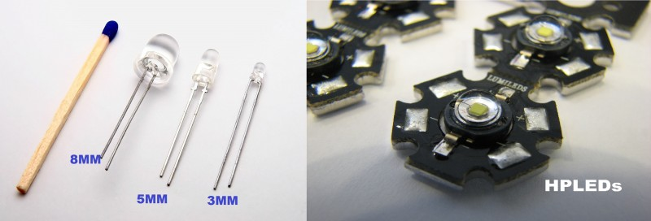
Fig 3.13: Types of LEDs
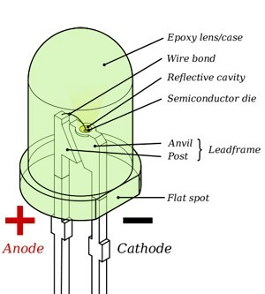

F
Operating parameters & circuit symbol – Above figures show basic elements inside the LED and circuit symbol which helps in interfacing LED with 8051. Typical current ratings range from around 1 mA to above 20 mA and voltage is at about colours.
- 1.9 to 2.1 V for red, orange and yellow,
- 3.0 to 3.4 V for green and blue,
- 2.9 to 4.2 V for violet, pink, purple and white.
- 5 V and 12 V LEDs are incorporate a suitable series resistor for direct connection to a 5 V or 12 V supply.

Applications-
LED is everywhere because it’s an indicating component used in many areas. Just look around, if u can’t find even single LED, you are not on earth.
ULN2003:-
The ULN2003 is a monolithic IC consists of seven NPN darlington transistor pairs with high voltage and current capability. It is commonly used for applications such as relay drivers, motor, display drivers, led lamp drivers, logic buffers, line drivers, hammer drivers and other high voltage current applications. It consists of common cathode clamp diodes for each NPN darlington pair which makes this driver IC useful for switching inductive loads.
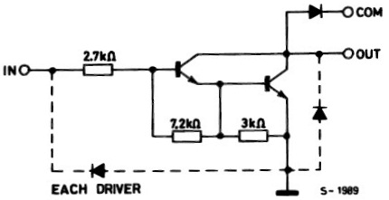

Fig 3.14: Circuit Diagram of ULN2003
The output of the driver is open collector and the collector current rating of each darlington pair is 500mA. Darlington pairs may be paralleled if higher current is required. The driver IC also consists of a 2.7KΩ base resistor for each darlington pair. Thus each darlington pair can be operated directly with TTL or 5V CMOS devices. This driver IC can be used for high voltage applications up to 50V.
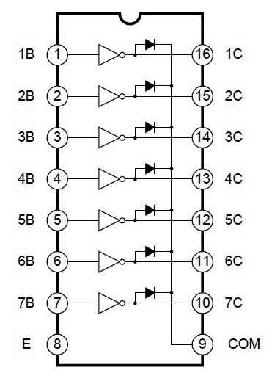
Fig 3.15: Logic Diagram of ULN2003
Note that the driver provides open collector output, so it can only sink current, cannot source. Thus when a 5V is given to 1B terminal, 1C terminal will be connected to ground via darlington pair and the maximum current that it can handle is 500A. From the above logic diagram we can see that cathode of protection diodes are shorted to 9th pin called COM. So for driving inductive loads, it must connect to the supply voltage.
ULN2003 is widely used in relay driving and stepper motor driving applications.

FEATURES
* 500mA rated collector current (Single output)
* High-voltage outputs: 50V
* Inputs compatible with various types of logic.
* Relay driver application

RELAY

INTRODUCTION
A relay is an electromechanical switch, which perform ON and OFF operations without any human interaction. General representation of double contact relay is shown in fig. Relays are used where it is necessary to control a circuit by a low-power signal (with complete electrical isolation between control and controlled circuits), or where several circuits must be controlled by one signal.
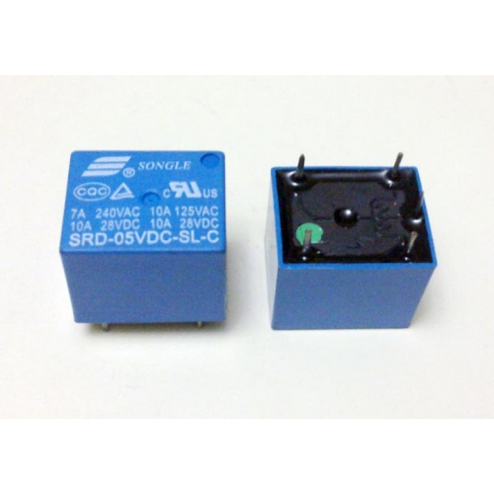
Fig 3.16 Relay
History
The first relay was invented by Joseph Henry in 1835. The name relay derives from the French noun relays’ that indicates the horse exchange place of the postman. Generally a relay is an electrical hardware device having an input and output gate. The output gate consists in one or more electrical contacts that switch when the input gate is electrically excited. It can implement a decoupled, a router or breaker for the electrical power, a negation, and, on the base of the wiring, complicated logical functions containing and, or, and flip-flop. In the past relays had a wide use, for instance the telephone switching or the railway routing and crossing systems. In spite of electronic progresses (as programmable devices), relays are still used in applications where ruggedness, simplicity, long life and high reliability are important factors (for instance in safety applications)

Working
Generally, the relay consists a inductor coil, a spring (not shown in the figure), Swing terminal, and two high power contacts named as normally closed (NC) and normally opened (NO). Relay uses an Electromagnet to move swing terminal between two contacts (NO and NC). When there is no power applied to the inductor coil (Relay is OFF), the spring holds the swing terminal is attached to NC contact.
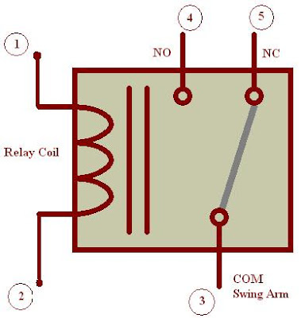
Fig 3.17 Representation of Relay
Whenever required power is applied to the inductor coil, the current flowing through the coil generates a magnetic field which is helpful to move the swing terminal and attached it to the normally open (NO) contact. Again when power is OFF, the spring restores the swing terminal position to NC.

Advantage of relay:
A relay takes small power to turn ON, but it can control high power devices to switch ON and OFF. Consider an example; a relay is used to control the ceiling FAN at our home. The ceiling FAN may runs at 230V AC and draws a current maximum of 4A. Therefore the power required is 4X230 = 920 watts. Off course we can control AC, lights, etc., depend up on the relay ratings. Relays can be used to control DC motors in ROBOTICs.

DC MOTOR
A DC motor in simple words is a device that converts direct current(electrical energy) into mechanical energy. It’s of vital importance for the industry today.
A DC motor is designed to run on DC electric power. Two examples of pure DC designs are Michael Faraday's homo-polar motor (which is uncommon), and the ball bearing motor, which is (so far) a novelty.
By far the most common DC motor types are the brushed and brushless types, which use internal and external commutation respectively to create an oscillating AC current from the DC source—so they are not purely DC machines in a strict sense.
We in our project are using brushed DC Motor, which will operate in the ratings of 12v DC 0.6A.
The speed of a DC motor can be controlled by changing the voltage applied to the armature or by changing the field current. The introduction of variable resistance in the armature circuit or field circuit allowed speed control. Modern DC motors are often controlled by power electronics systems called DC drives.
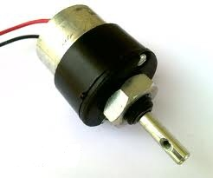
Fig 3.18 Motor

Usage
The DC motor or Direct Current Motor to give it its full title, is the most commonly used actuator for producing continuous movement and whose speed of rotation can easily be controlled, making them ideal for use in applications were speed control, servo type control, and/or positioning is required. A DC motor consists of two parts, a "Stator" which is the stationary part and a "Rotor" which is the rotating part. The result is that there are basically three types of DC Motor available.

7 SOFTWARE SPECIFICATION
The Arduino Integrated Development Environment
Arduino Software (IDE) - contains a text editor for writing code, a message area, a text console, a toolbar with buttons for common functions and a series of menus. It connects to the Arduino and Genuino hardware to upload programs and communicate with them.

Writing Sketches
Programs written using Arduino Software (IDE) are called sketches. These sketches are written in the text editor and are saved with the file extension .ino. The editor has features for cutting/pasting and for searching/replacing text. The message area gives feedback while saving and exporting and also displays errors. The console displays text output by the Arduino Software (IDE), including complete error messages and other information. The bottom righthand corner of the window displays the configured board and serial port. The toolbar buttons allow you to verify and upload programs, create, open, and save sketches, and open the serial monitor.
NB: Versions of the Arduino Software (IDE) prior to 1.0 saved sketches with the extension .pde. It is possible to open these files with version 1.0, you will be prompted to save the sketch with the .ino extension on save.
Verify
Checks your code for errors compiling it.
Upload
Compiles your code and uploads it to the configured board. See uploading below for details.
Note: If you are using an external programmer with your board, you can hold down the "shift" key on your computer when using this icon. The text will change to "Upload using Programmer"
New
Creates a new sketch.
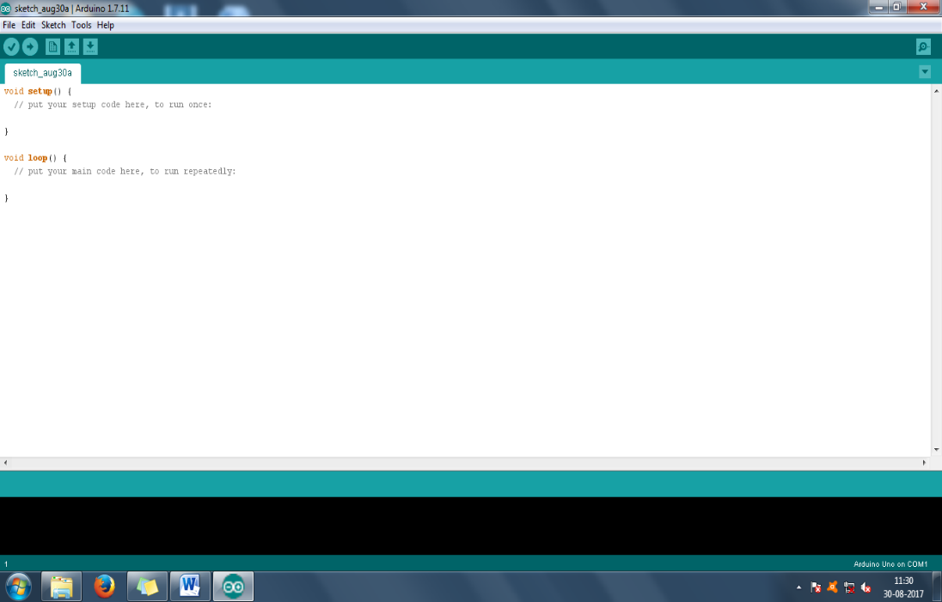
Open
Presents a menu of all the sketches in your sketchbook. Clicking one will open it within the current window overwriting its content.
Note: due to a bug in Java, this menu doesn't scroll; if you need to open a sketch late in the list, use the File | Sketchbookmenu instead.
Save
Saves your sketch.
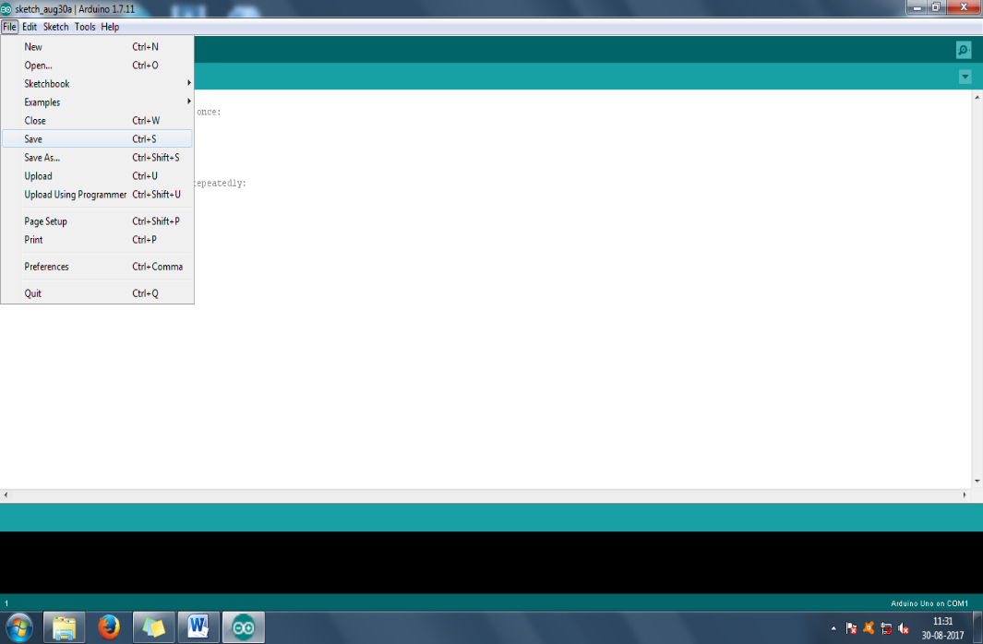
Serial Monitor
Opens the serial monitor.
Additional commands are found within the five menus: File, Edit, Sketch, Tools, Help. The menus are context sensitive, which means only those items relevant to the work currently being carried out are available.

File
- New
Creates a new instance of the editor, with the bare minimum structure of a sketch already in place.
- Open
Allows to load a sketch file browsing through the computer drives and folders.
- Open Recent
Provides a short list of the most recent sketches, ready to be opened.
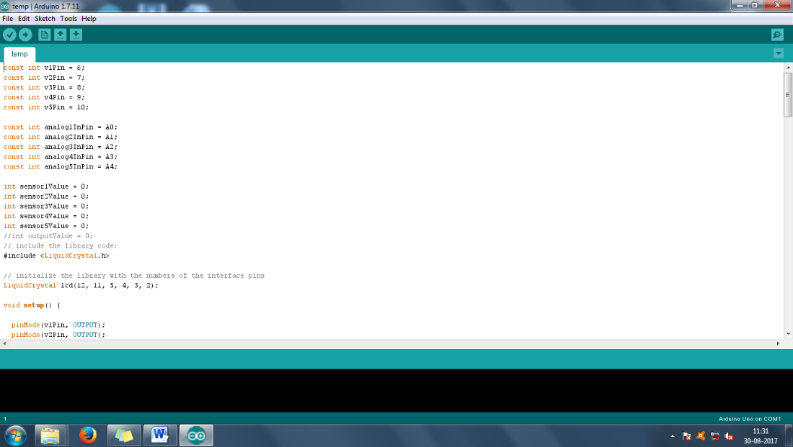
- Sketchbook
Shows the current sketches within the sketchbook folder structure; clicking on any name opens the corresponding sketch in a new editor instance.
- Examples
Any example provided by the Arduino Software (IDE) or library shows up in this menu item. All the examples are structured in a tree that allows easy access by topic or library.
- Close
Closes the instance of the Arduino Software from which it is clicked.
- Save
Saves the sketch with the current name. If the file hasn't been named before, a name will be provided in a "Save as.." window.
- Save as...
Allows to save the current sketch with a different name.
- Page Setup
It shows the Page Setup window for printing.
- Print
Sends the current sketch to the printer according to the settings defined in Page Setup.
- Preferences
Opens the Preferences window where some settings of the IDE may be customized, as the language of the IDE interface.
- Quit
Closes all IDE windows. The same sketches open when Quit was chosen will be automatically reopened the next time you start the IDE.

Edit
- Undo/Redo
Goes back of one or more steps you did while editing; when you go back, you may go forward with Redo.
- Cut
Removes the selected text from the editor and places it into the clipboard.
- Copy
Duplicates the selected text in the editor and places it into the clipboard.
- Copy for Forum
Copies the code of your sketch to the clipboard in a form suitable for posting to the forum, complete with syntax coloring.
- Copy as HTML
Copies the code of your sketch to the clipboard as HTML, suitable for embedding in web pages.
- Paste
Puts the contents of the clipboard at the cursor position, in the editor.
- Select All
Selects and highlights the whole content of the editor.
- Comment/Uncomment
Puts or removes the // comment marker at the beginning of each selected line.
- Increase/Decrease Indent
Adds or subtracts a space at the beginning of each selected line, moving the text one space on the right or eliminating a space at the beginning.
- Find
Opens the Find and Replace window where you can specify text to search inside the current sketch according to several options.
- Find Next
Highlights the next occurrence - if any - of the string specified as the search item in the Find window, relative to the cursor position.
- Find Previous
Highlights the previous occurrence - if any - of the string specified as the search item in the Find window relative to the cursor position.

Sketch
- Verify/Compile
Checks your sketch for errors compiling it; it will report memory usage for code and variables in the console area.
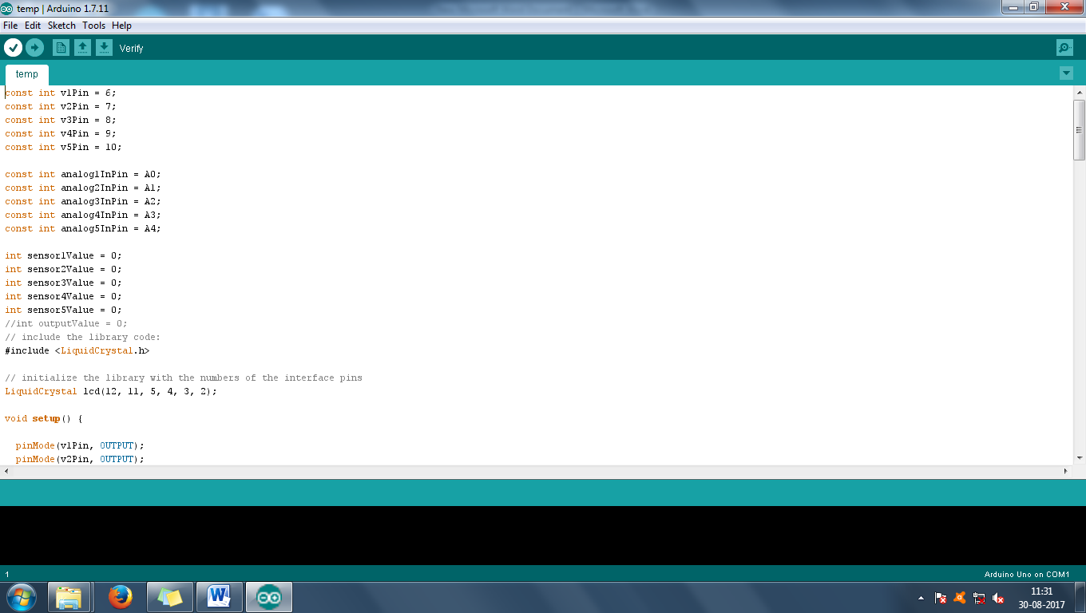
- Upload
Compiles and loads the binary file onto the configured board through the configured Port.
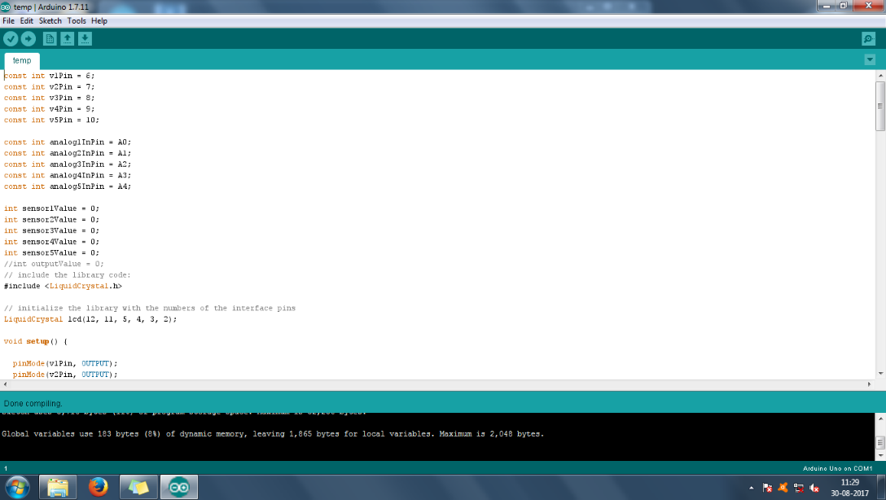
- Upload Using Programmer
This will overwrite the bootloader on the board; you will need to use Tools > Burn Bootloader to restore it and be able to Upload to USB serial port again. However, it allows you to use the full capacity of the Flash memory for your sketch. Please note that this command will NOT burn the fuses. To do so a Tools -> Burn Bootloader command must be executed.
- Export Compiled Binary
Saves a .hex file that may be kept as archive or sent to the board using other tools.
- Show Sketch Folder
Opens the current sketch folder.
- Include Library
Adds a library to your sketch by inserting #include statements at the start of your code. For more details, see libraries below. Additionally, from this menu item you can access the Library Manager and import new libraries from .zip files.
- Add File...
Adds a source file to the sketch (it will be copied from its current location). The new file appears in a new tab in the sketch window. Files can be removed from the sketch using the tab menu accessible clicking on the small triangle icon below the serial monitor one on the right side o the toolbar.

Tools
- Auto Format
This formats your code nicely: i.e. indents it so that opening and closing curly braces line up, and that the statements inside curly braces are indented more.
- Archive Sketch
Archives a copy of the current sketch in .zip format. The archive is placed in the same directory as the sketch.
- Fix Encoding & Reload
Fixes possible discrepancies between the editor char map encoding and other operating systems char maps.
- Serial Monitor
Opens the serial monitor window and initiates the exchange of data with any connected board on the currently selected Port. This usually resets the board, if the board supports Reset over serial port opening.
- Board
Select the board that you're using. See below for descriptions of the various boards.
- Port
This menu contains all the serial devices (real or virtual) on your machine. It should automatically refresh every time you open the top-level tools menu.
- Programmer
For selecting a harware programmer when programming a board or chip and not using the onboard USB-serial connection. Normally you won't need this, but if you're burning a bootloader to a new microcontroller, you will use this.
- Burn Bootloader
The items in this menu allow you to burn a bootloader onto the microcontroller on an Arduino board. This is not required for normal use of an Arduino or Genuino board but is useful if you purchase a new ATmega microcontroller (which normally come without a bootloader). Ensure that you've selected the correct board from the Boards menu before burning the bootloader on the target board. This command also set the right fuses.

Help
Here you find easy access to a number of documents that come with the Arduino Software (IDE). You have access to Getting Started, Reference, this guide to the IDE and other documents locally, without an internet connection. The documents are a local copy of the online ones and may link back to our online website.
- Find in Reference
This is the only interactive function of the Help menu: it directly selects the relevant page in the local copy of the Reference for the function or command under the cursor.

Sketchbook
The Arduino Software (IDE) uses the concept of a sketchbook: a standard place to store your programs (or sketches). The sketches in your sketchbook can be opened from the File >Sketchbook menu or from the Open button on the toolbar. The first time you run the Arduino software, it will automatically create a directory for your sketchbook. You can view or change the location of the sketchbook location from with the Preferences dialog.
Beginning with version 1.0, files are saved with a .ino file extension. Previous versions use the .pde extension. You may still open .pde named files in version 1.0 and later, the software will automatically rename the extension to .ino.

Tabs, Multiple Files, and Compilation
Allows you to manage sketches with more than one file (each of which appears in its own tab). These can be normal Arduino code files (no visible extension), C files (.c extension), C++ files (.cpp), or header files (.h).

Uploading
Before uploading your sketch, you need to select the correct items from the Tools > Board and Tools > Port menus. The boards are described below. On the Mac, the serial port is probably something like /dev/tty.usbmodem241 (for an Uno or Mega2560 or Leonardo) or /dev/tty.usbserial-1B1 (for a Duemilanove or earlier USB board), or /dev/tty.USA19QW1b1P1.1 (for a serial board connected with a Keyspan USB-to-Serial adapter). On Windows, it's probably COM1 or COM2 (for a serial board) or COM4, COM5, COM7, or higher (for a USB board) - to find out, you look for USB serial device in the ports section of the Windows Device Manager. On Linux, it should be /dev/ttyACMx , /dev/ttyUSBx or similar. Once you've selected the correct serial port and board, press the upload button in the toolbar or select the Upload item from the Sketch menu. Current Arduino boards will reset automatically and begin the upload. With older boards (pre-Diecimila) that lack auto-reset, you'll need to press the reset button on the board just before starting the upload. On most boards, you'll see the RX and TX LEDs blink as the sketch is uploaded. The Arduino Software (IDE) will display a message when the upload is complete, or show an error.
When you upload a sketch, you're using the Arduino bootloader, a small program that has been loaded on to the microcontroller on your board. It allows you to upload code without using any additional hardware. The bootloader is active for a few seconds when the board resets; then it starts whichever sketch was most recently uploaded to the microcontroller. The bootloader will blink the on-board (pin 13) LED when it starts (i.e. when the board resets).

Libraries
Libraries provide extra functionality for use in sketches, e.g. working with hardware or manipulating data. To use a library in a sketch, select it from the Sketch > Import Library menu. This will insert one or more #include statements at the top of the sketch and compile the library with your sketch. Because libraries are uploaded to the board with your sketch, they increase the amount of space it takes up. If a sketch no longer needs a library, simply delete its #includestatements from the top of your code.
There is a list of libraries in the reference. Some libraries are included with the Arduino software. Others can be downloaded from a variety of sources or through the Library Manager. Starting with version 1.0.5 of the IDE, you do can import a library from a zip file and use it in an open sketch. See these instructions for installing a third-party library.
To write your own library, see this tutorial.

Third-Party Hardware
Support for third-party hardware can be added to the hardware directory of your sketchbook directory. Platforms installed there may include board definitions (which appear in the board menu), core libraries, bootloaders, and programmer definitions. To install, create the hardware directory, then unzip the third-party platform into its own sub-directory. (Don't use "arduino" as the sub-directory name or you'll override the built-in Arduino platform.) To uninstall, simply delete its directory.
For details on creating packages for third-party hardware, see the Arduino IDE 1.5 3rd party Hardware specification.

Serial Monitor
Displays serial data being sent from the Arduino or Genuino board (USB or serial board). To send data to the board, enter text and click on the "send" button or press enter. Choose the baud rate from the drop-down that matches the rate passed to Serial.begin in your sketch. Note that on Windows, Mac or Linux, the Arduino or Genuino board will reset (rerun your sketch execution to the beginning) when you connect with the serial monitor.
You can also talk to the board from Processing, Flash, MaxMSP, etc (see the interfacing page for details).

Preferences
Some preferences can be set in the preferences dialog (found under the Arduino menu on the Mac, or File on Windows and Linux). The rest can be found in the preferences file, whose location is shown in the preference dialog.

Language Support
Since version 1.0.1, the Arduino Software (IDE) has been translated into 30+ different languages. By default, the IDE loads in the language selected by your operating system. (Note: on Windows and possibly Linux, this is determined by the locale setting which controls currency and date formats, not by the language the operating system is displayed in.)


Since version 1.0.1, the Arduino Software (IDE) has been translated into 30+ different languages. By default, the IDE loads in the language selected by your operating system. (Note: on Windows and possibly Linux, this is determined by the locale setting which controls currency and date formats, not by the language the operating system is displayed in.)
If you would like to change the language manually, start the Arduino Software (IDE) and open the Preferences window. Next to the Editor Language there is a dropdown menu of currently supported languages. Select your preferred language from the menu, and restart the software to use the selected language. If your operating system language is not supported, the Arduino Software (IDE) will default to English.
You can return the software to its default setting of selecting its language based on your operating system by selecting System Default from the Editor Language drop-down. This setting will take effect when you restart the Arduino Software (IDE). Similarly, after changing your operating system's settings, you must restart the Arduino Software (IDE) to update it to the new default language.

Boards
The board selection has two effects: it sets the parameters (e.g. CPU speed and baud rate) used when compiling and uploading sketches; and sets and the file and fuse settings used by the burn bootloader command. Some of the board definitions differ only in the latter, so even if you've been uploading successfully with a particular selection you'll want to check it before burning the bootloader. You can find a comparison table between the various boards here.
Arduino Software (IDE) includes the built in support for the boards in the following list, all based on the AVR Core. The Boards Manager included in the standard installation allows to add support for the growing number of new boards based on different cores like Arduino Due, Arduino Zero, Edison, Galileo and so on.

CHAPTER 4
RESULT AND DISCUSSION

IMPLEMENTATION
4.1 CODE
#include <Wire.h>
#include <ESP8266WiFi.h>
#include <SoftwareSerial.h>
#include "ThingSpeak.h"
#include <Adafruit_GFX.h>
#include <Adafruit_SSD1306.h>
#define SCREEN_WIDTH 128 // OLED display width, in pixels
#define SCREEN_HEIGHT 64 // OLED display height, in pixels
// Declaration for an SSD1306 display connected to I2C (SDA, SCL pins)
Adafruit_SSD1306 display(SCREEN_WIDTH, SCREEN_HEIGHT, &Wire, -1);
#define mot1 14
#define mot2 12
String command;
const char* ssid = "project"; // your network SSID (name)
const char* password = "123456789"; // your network password
WiFiClient client;
unsigned long myChannelNumber = 2370547;
const char* myWriteAPIKey = "B7ZTS3X15IYJB9IF";
void setup() {
Serial.begin(9600);
pinMode(mot2, OUTPUT);
pinMode(mot1, OUTPUT);
delay(200);
if (!display.begin(SSD1306_SWITCHCAPVCC, 0x3C)) { // Address 0x3D for 128x64
Serial.println(F("SSD1306 allocation failed"));
for (;;)
;
}
delay(1000);
display.clearDisplay();
display.setTextSize(1);
display.setTextColor(WHITE);
display.setCursor(0, 0);
display.println("IOT POWERED GRID MANAGEMENT");
display.display();
delay(2000);
WiFi.mode(WIFI_STA);
ThingSpeak.begin(client);
// Connect or reconnect to WiFi
if (WiFi.status() != WL_CONNECTED) {
Serial.print("Attempting to connect");
while (WiFi.status() != WL_CONNECTED) {
WiFi.begin(ssid, password);
delay(5000);
}
}
digitalWrite(mot1, HIGH);
digitalWrite(mot2, LOW);
}
char x, y;
void loop() {

while (Serial.available()) {
command = "";
command = Serial.readString();
display.clearDisplay();
display.setTextSize(1);
display.setTextColor(WHITE);
display.setCursor(10, 0);
display.println("Instruction");
display.println(command);
display.display();
delay(2000);
if (command == "*bulb on#") {

display.setTextSize(1);
display.setTextColor(WHITE);
display.setCursor(0, 20);
display.println("BULB ON");
display.display();
digitalWrite(mot1, HIGH);
// digitalWrite(mot2, LOW);
delay(1500);
ThingSpeak.setField(1, '1');
ThingSpeak.writeFields(myChannelNumber, myWriteAPIKey);
} else if (command == "*fan on#") {
y = 1;
display.setTextSize(1);
display.setTextColor(WHITE);
display.setCursor(0, 20);
display.println("FAN ON");
display.display();
// digitalWrite(mot1, HIGH);
digitalWrite(mot2, HIGH);
delay(1500);
ThingSpeak.setField(2, '1');
ThingSpeak.writeFields(myChannelNumber, myWriteAPIKey);
} else if (command == "*fan off#") {
y = 0;
display.setTextSize(1);
display.setTextColor(WHITE);
display.setCursor(0, 20);
display.println("FAN OFF");
display.display();
digitalWrite(mot2, LOW);
delay(1500);
ThingSpeak.setField(2, '0');
ThingSpeak.writeFields(myChannelNumber, myWriteAPIKey);

} else if (command == "*bulb off#") {
x = 0;
display.setTextSize(1);
display.setTextColor(WHITE);
display.setCursor(0, 20);
display.println("BULB OFF");
display.display();
digitalWrite(mot1, LOW);
delay(1500);
ThingSpeak.setField(1, '0');
ThingSpeak.writeFields(myChannelNumber, myWriteAPIKey);
}
command = "";
delay(1000);
}
}

4.2 SCHEMATIC

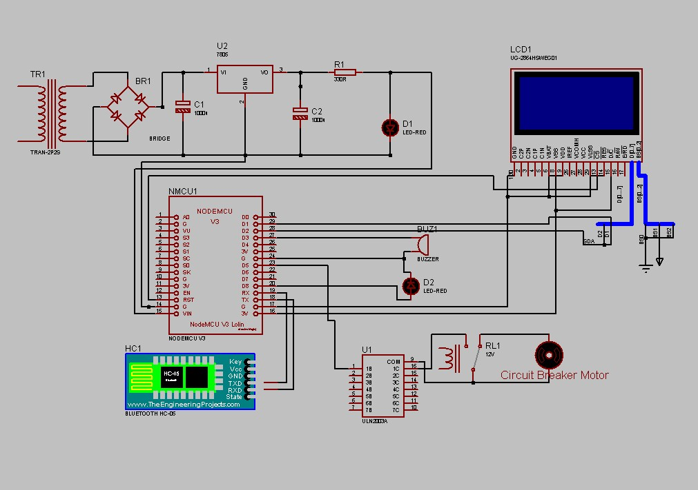

4.3 OUTPUT SCREEN SHOTS
Working :
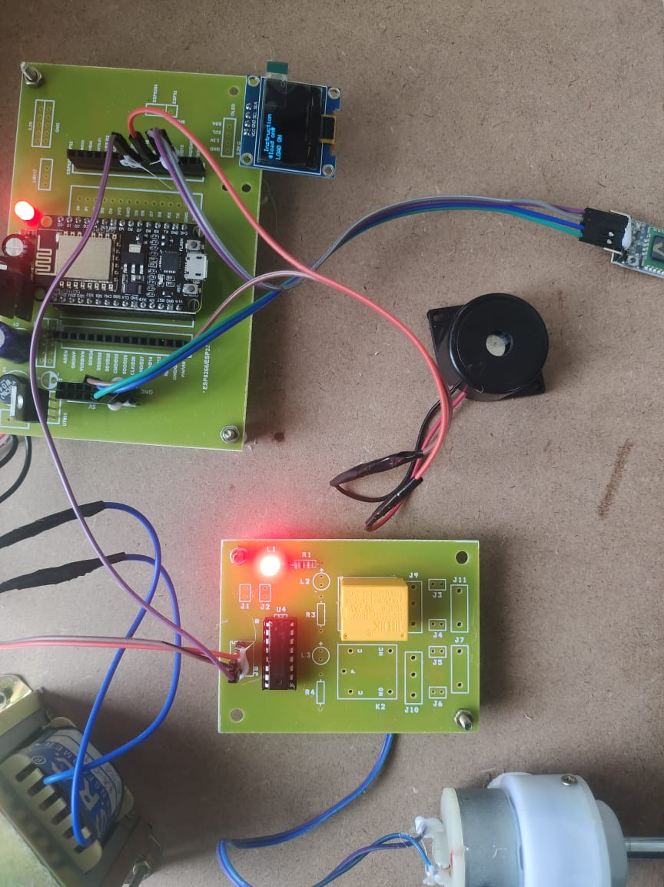

Circuit breaker Graph:

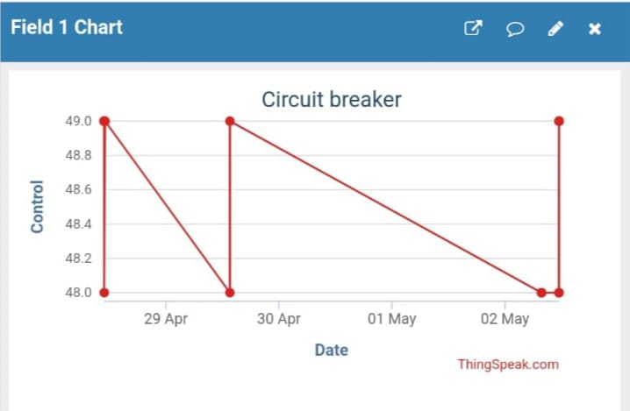

CHAPTER 5

CONCLUSION
In this paper, we breifly studied about the IOT based smart grid system. Smart grid represents one of the most promising and prominent internet of thing application. By applying IOT technologies , various intelligent services can be created. The development of most aspects of the smart grid would be enhanced by applying IOT. It provides very effective measures of delivering electric power to various consumers.

REFERENCES:
(1) International reasearch journel of engineering and technology (IRJET). Internet of things based on smart grid, Shahid Yusuf wani, shaver Sharma.
(2) a review on iot based smart grid, maninder kaur and Dr. Sheetal Kalra.
(3)] U. S. DOE, “Communications requirements of Smart Grid technologies,” Tech. Rep., US Department of Energy, 2010, http://energy.gov/gc/downloads/communicationsrequirements-smart-grid-technologies.
(4) U. S. Department of Energy, Smart grid type @ONLINE, June.
(5) https://www.eesi.org
(6) Design of IoT Based Monitoring System for Miniature Smart Grid Waluyo, Febrian Hadiatna, Andre Widura

